|  |  |  |  |  |
| --- | --- | --- | --- | --- |
|  |  | | |  |
| **Huawei eSight for vCenter Plug-in**  **V1.6.156** | | |
| **User Guide** | | |
| **Issue** | **01** | |
| **Date** | **2020-05-06** | |
|  | | | | |
|  | HUAWEI TECHNOLOGIES CO., LTD. | |  |  |

|  |
| --- |
| **Copyright © Huawei Technologies Co., Ltd. 2020. All rights reserved.**  No part of this document may be reproduced or transmitted in any form or by any means without prior written consent of Huawei Technologies Co., Ltd.  **Trademarks and Permissions**  and other Huawei trademarks are trademarks of Huawei Technologies Co., Ltd.  All other trademarks and trade names mentioned in this document are the property of their respective holders.  **Notice**  The purchased products, services and features are stipulated by the contract made between Huawei and the customer. All or part of the products, services and features described in this document may not be within the purchase scope or the usage scope. Unless otherwise specified in the contract, all statements, information, and recommendations in this document are provided "AS IS" without warranties, guarantees or representations of any kind, either express or implied.  The information in this document is subject to change without notice. Every effort has been made in the preparation of this document to ensure accuracy of the contents, but all statements, information, and recommendations in this document do not constitute a warranty of any kind, express or implied. |

|  |  |
| --- | --- |
| Huawei Technologies Co., Ltd. | |
| Address: | Huawei Industrial Base  Bantian, Longgang  Shenzhen 518129  People's Republic of China |
| Website: | <https://e.huawei.com> |
|  |  |

About This Document

Purpose

This document describes how to install and maintain the vCenter plug-in.

Intended Audience

This document is intended for:

* Technical support engineers
* System maintenance engineer

Symbol Conventions

The symbols that may be found in this document are defined as follows.

| Symbol | Description |
| --- | --- |
|  | Indicates an imminently hazardous situation which, if not avoided, will result in death or serious injury. |
|  | Indicates a potentially hazardous situation which, if not avoided, could result in death or serious injury. |
|  | Indicates a potentially hazardous situation which, if not avoided, may result in minor or moderate injury. |
|  | Indicates a potentially hazardous situation which, if not avoided, could result in equipment damage, data loss, performance deterioration, or unanticipated results.  NOTICE is used to address practices not related to personal injury. |
|  | Calls attention to important information, best practices and tips.  NOTE is used to address information not related to personal injury, equipment damage, and environment deterioration. |

Change History

Changes between document issues are cumulative. The latest document issue contains all the changes made in earlier issues.

| Issue | Release Date | Description |
| --- | --- | --- |
| 01 | 2020-05-06 | This issue is the first official release. |

Contents

About This Document ii

1 Overview 1

2 Installing and Uninstalling the Huawei vCenter Plug-in 3

2.1 Installing the Huawei vCenter Plug-In 3

2.2 Uninstalling the Huawei vCenter Plug-in 15

2.3 Upgrading the Huawei vCenter Plug-in 26

3 Operation and Maintenance 28

3.1 Configuring eSight 28

3.1.1 Adding an eSight 28

3.1.2 Editing an eSight 32

3.1.3 Deleting eSight 34

3.2 Managing Servers 34

3.2.1 Viewing the Server List 34

3.2.2 Deploying an OS 36

3.2.2.1 Adding a Software Source 36

3.2.2.2 Creating an OS Template 39

3.2.2.3 Creating a Template Task 41

3.2.3 Managing Templates 43

3.2.3.1 Configuring Power Control 43

3.2.3.2 Configuring the BIOS 44

3.2.3.3 Configuring an HBA 53

3.2.3.4 Configuring RAID 55

3.2.3.5 Configuring a CNA 57

3.2.3.6 Configuring the iBMC 60

3.2.4 Upgrading the Firmware and Driver 64

3.2.4.1 Uploading an Upgrade Package 64

3.2.4.2 Upgrading the Firmware and Driver 66

3.2.5 Registering, Configuring, and Using Proactive HA 68

3.2.5.1 Registering the HA Provider 68

3.2.5.2 Configuring Proactive HA 71

3.2.5.3 Using Proactive HA 74

3.2.6 Receiving and Viewing Server Alarms 75

3.3 Viewing the Huawei vCenter Plug-in Version 78

4 FAQs 79

4.1 Connection Test Failed When Adding an eSight 79

4.2 Failed to Deploy an OS 82

4.3 Failed to Upload an Upgrade Package 85

4.4 How to Add a Server ESXi System to a vCenter Cluster 85

4.5 Icon of the eSight For vCenter Not Displayed in the vCenter Home Page 87

4.6 Failed to Start the Huawei vCenter Plug-in Installation Program and Deployment Program 90

4.7 On the Huawei vCenter Plugin Update Program Page, "Please put zip file and refresh the page" Is Displayed 91

4.8 RAID Controller Card Slot Number Is Empty in the RAID Controller Card Template Details 91

A Obtaining Help 94

A.1 Preparing to Contact Huawei Technical Support 94

A.2 Obtaining Help from Huawei Support Website 94

# Overview

Function Description

The Huawei vCenter plug-in is integrated in the vCenter software and used for Huawei server management. By adding eSight, you can deploy OSs, configure servers, upgrade, and monitor Huawei servers.

You can implement the following functions by using this plug-in:

* View server information and component information.
* Deploy server OSs in batches. For the supported OS types and versions, see Table 3-1.
* Configure CNAs, HBAs, BMCs, BIOSs, and RAIDs of servers.
* Upgrade server firmware and drivers.
* Provide Proactive HA Provider to implement isolation functions on abnormal servers.



The actual functions depend on the functions provided by eSight.

Supported Servers

| Type | Server Model |
| --- | --- |
| Rack server | RH2288H V2 |
| RH1288 V3 |
| RH2288 V3 |
| RH2288H V3 |
| RH5885 V3 |
| RH8100 V3 |
| 1288H V5 |
| 2288H V5 |
| 2488 V5 |
| Blade server | CH121 V3 |
| CH242 V3 |
| Chassis | E9000 (MM910) |
| High-density server | XH321 V3 |
| XH620 V3 |
| XH622 V3 |
| XH628 V3 |

# Installing and Uninstalling the Huawei vCenter Plug-in

2.1 Installing the Huawei vCenter Plug-In

2.2 Uninstalling the Huawei vCenter Plug-in

2.3 Upgrading the Huawei vCenter Plug-in

## Installing the Huawei vCenter Plug-In

Prerequisites

* You have installed JRE 1.8.0 or later on the Windows host.
* You have obtained the Huawei vCenter plug-in installation package [Huawei vCenter Plugin X.X.zip](https://github.com/Huawei/Server_Management_Plugin_vCenter/tree/master/releases) and the deployment software package Huawei vCenter Plugin Upgrade *X.X*.zip. Here, *X.X* indicates the plug-in version number, for example, **Huawei vCenter Plugin 1.0.zip**.
* You have prepared a host running a Windows OS for installing and running the deployment program package. The deployment program package supports only Windows OSs.



Ensure that the firewall of the Windows OS is disabled. Otherwise, the installation or uninstallation fails and the plug-in cannot be installed or uninstalled again.

Hardware Requirements

Recommended configurations:

* CPU: 8-core 2 GHz
* Memory capacity: 16 GB
* Hard disk: 500 GB

Procedure

Log in to the Windows host for installing the deployment program package as an administrator, and upload the Huawei vCenter plug-in installation package and deployment program package to the host.

Modify the Java environment variable.

Windows Server 2012 R2 is used as an example.

1. In Control Panel, select **Category** from the **View by** drop-down list box.
2. Choose **System and Security** > **System** > **Advanced system settings**.

The **System Properties** dialog box is displayed.

1. On the **Advanced** tab page, click **Environment Variables**, as shown in Figure 2-1.

System Properties

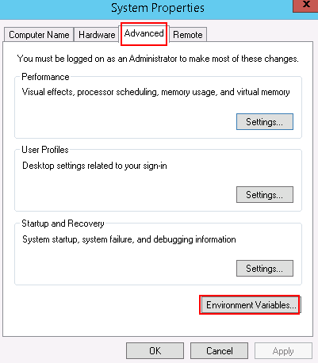

The **Environment Variables** dialog box is displayed.

1. In the **System Variables** area, select the **Path** variable, and click **Edit.**

The **Edit System Variable** dialog box is displayed.

1. Add a variable value, and click **OK**.

The value of **Variable value** is the actual JRE installation path. **C:\Program Files\Java\jre1.8.0_121\bin** is used as an example, as shown in Figure 2-2.

Edit System Variable

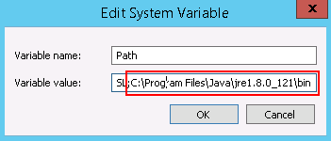

1. Click **OK**.
2. Click **Apply**, and click **OK**.
3. Run **CMD** to open the CLI window, and run **java -version** to view the JRE version.

Disable the firewall.

1. On **Control Panel**, choose **System and Security** > **Windows Firewall**, as shown in Figure 2-3.

Control Panel

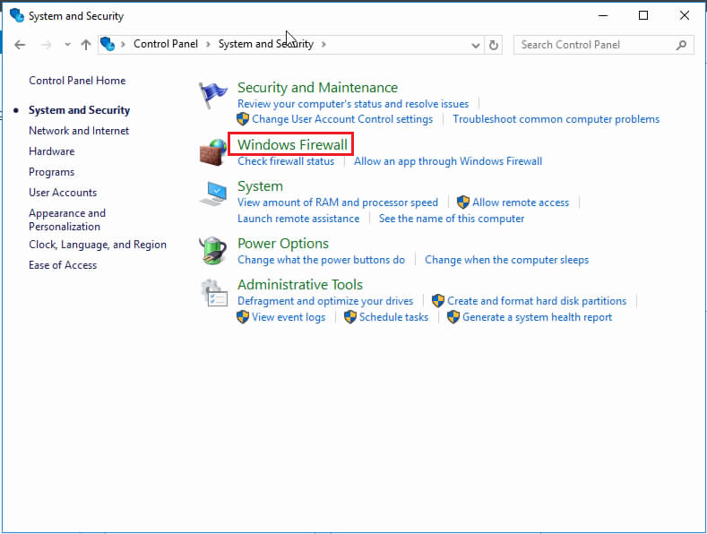

1. Click **Turn Windows Firewall on or off**, as shown in Figure 2-4.

Windows Firewall

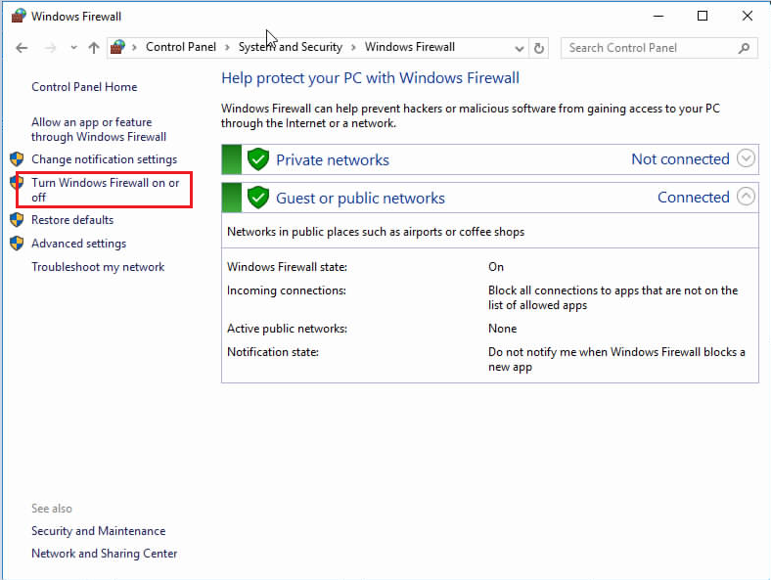

1. Select **Turn off Windows Firewall (not recommended)**, and click **OK**, as shown in Figure 2-5.

Disabling the Windows firewall

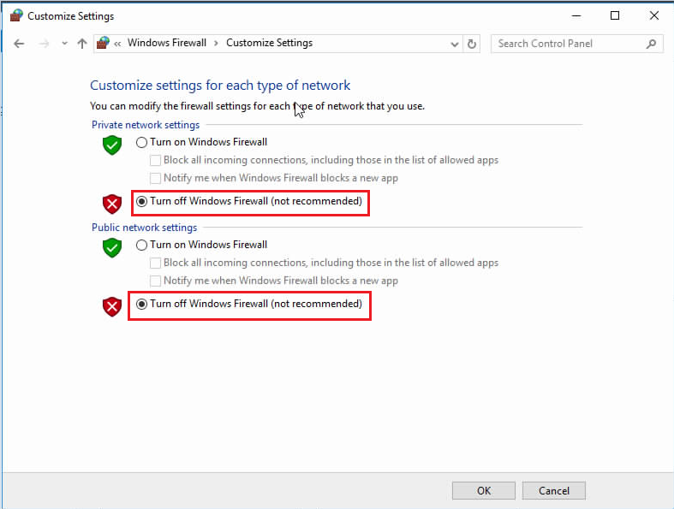

(Optional) Disable the domain controller firewall when a domain controller exists on the Windows host.

1. In **Server Manager**, choose **Tools** > **Windows Firewall with Advanced Security**.

The **Windows Firewall with Advanced Security** window is displayed, as shown in Figure 2-6.

Windows Firewall with Advanced Security

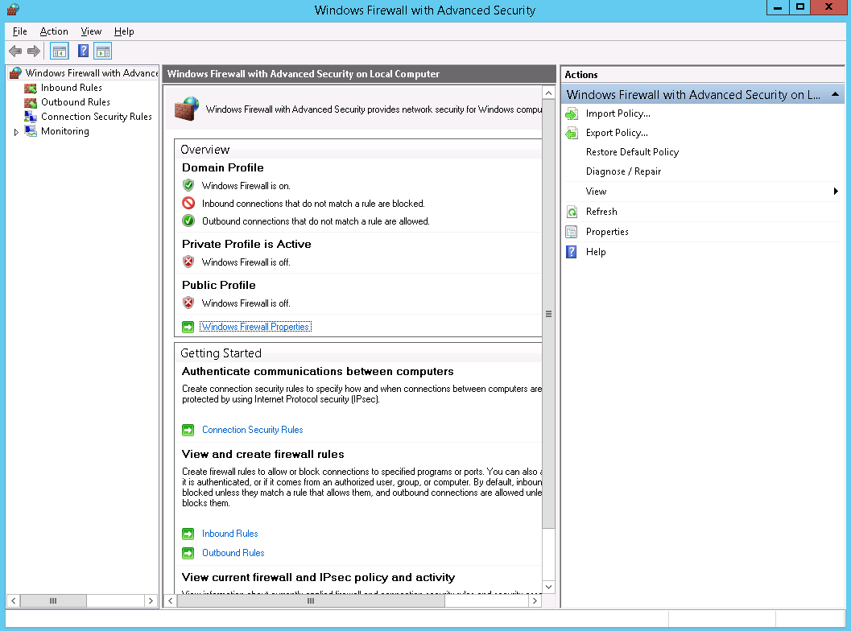

1. Choose **Windows Firewall Properties > Domain Profile**.

The **Domain Profile** tab is displayed, as shown in Figure 2-7.

Domain Profile

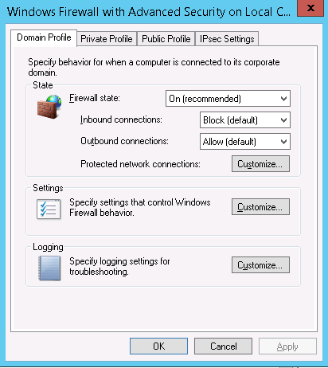

1. Set **Firewall state** to **Off**, and click **Apply**, as shown in Figure 2-8.

Disabling the domain controller firewall

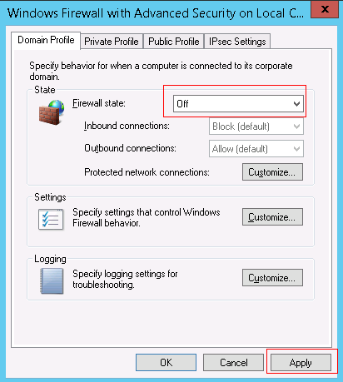

Decompress the deployment software package.



The Huawei vCenter plug-in installation package and the decompressed deployment program package (.jar file) must be stored in the same folder.

Run **CMD** to open the CLI window, and run the following command to go to the path for storing the installation package and deployment software package:

**cd** *path for saving the software package and deployment software package*

Run the following command to start the deployment software package:



Keep the CLI window open when you install the Huawei vCenter plug-in. Otherwise, the installation page may fail to open.

**java -jar** *Deployment software package name***.jar**

If information shown in Figure 2-9 is displayed, the deployment software is started.

Command output

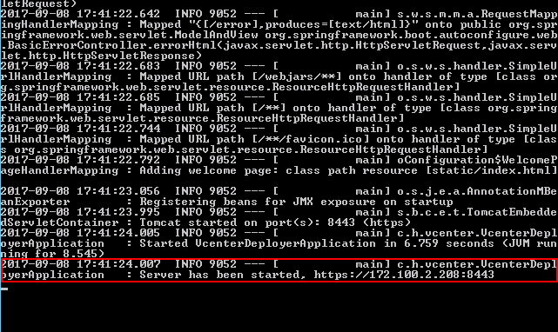

In the preceding command, **8443** is the default port number. To change the port number, run the following command:

**java -jar** *Deployment software package name***.jar --server.port=***Customized port number*

Open the browser on the local PC, enter **https://*Windows host IP address*:8443** in the address box, and press **Enter**. The IP address can be obtained from the last line of the command output in Step 7.

The **Huawei vCenter plugin update program** page is displayed, as shown in, as shown in Figure 2-10.

Huawei vCenter plugin update program

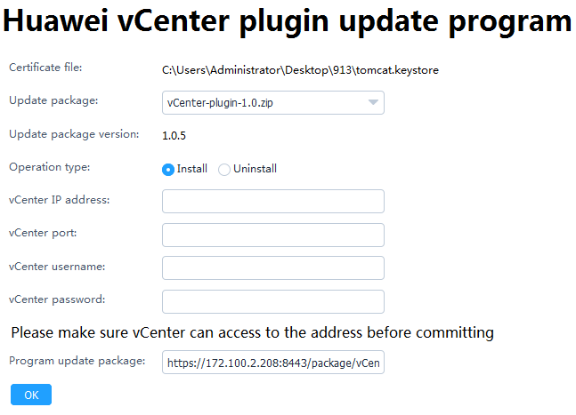

Set the following parameters, and click **OK**.

* **Update package**: Select the vCenter plug-in installation package.
* **Operation type**: Select **Install**.
* **vCenter IP address**: Enter the vCenter IP address where the plug-in is to be installed.
* **vCenter port**: Enter the vCenter port number. The default value is **443**.
* **vCenter username**: Enter the vCenter administrator user name.
* **vCenter password**: Enter the vCenter administrator password.

In the CLI window, view the command output. If information shown in Figure 2-11 is displayed, the Huawei vCenter plug-in is successfully installed.

Command output

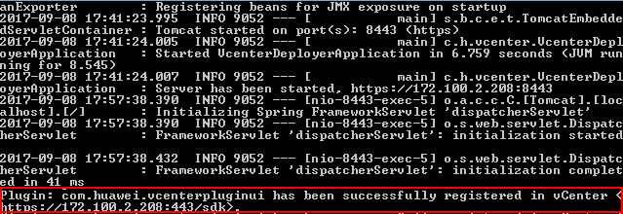

Restart the vCenter service.

* Restart vCenter in the Windows environment.
  1. Access the Windows CLI.
  2. Run the following command to stop the vCenter service:

"C:\Program Files\VMware\vCenter Server\bin\service-control.bat" --stop --all

* 1. Run the following command to start the vCenter service:

"C:\Program Files\VMware\vCenter Server\bin\service-control.bat" --start --all

* Restart vCenter in the Linux environment.
  1. Access the Linux CLI as user **root** by using the SSH tool.
  2. Run the following command to stop the vCenter service:

service-control --stop --all

* 1. Run the following command to start the vCenter service:

service-control --start --all

Open the browser on the local PC, enter **https://*vCenter IP address*** in the address box, and press **Enter**.

Select **Flash** to open the vCenter login page.

vCenter login

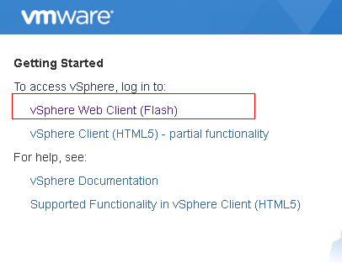

Enter the vCenter user name and password, and click **Login**.

The vCenter homepage is displayed.

If the icon in the red box shown in Figure 2-13 is displayed, the Huawei vCenter plug-in is successfully installed.

Homepage

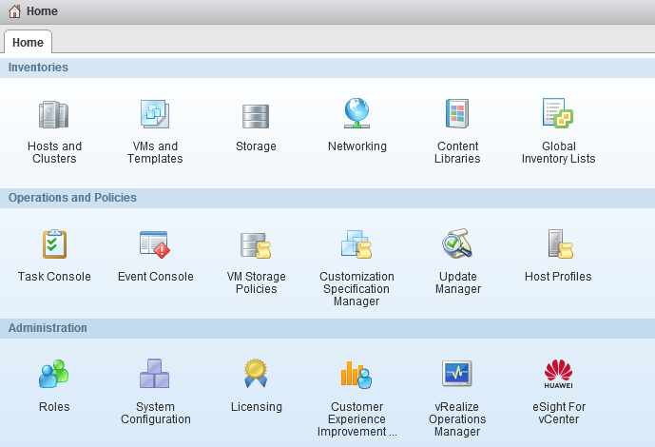

If you have logged in to vCenter, you need to log out and then log in again to view the **eSight For vCenter** icon.

----End

## Uninstalling the Huawei vCenter Plug-in

Prerequisites

* You have installed JRE 1.8.0 or later on the Windows host.
* You have obtained the Huawei deployment software package **Huawei vCenter Plugin Upgrade X.X.zip**, where X.X indicates the plug-in version.
* You have prepared a host running a Windows OS for installing and running the deployment program package. The deployment program package supports only Windows OSs.



Ensure that the firewall of the Windows OS is disabled. Otherwise, the installation or uninstallation fails and the plug-in cannot be installed or uninstalled again.

Procedure

Log in to the Windows host for installing the deployment program package as an administrator, and upload the Huawei vCenter plug-in installation package and deployment program package to the host.

Modify the Java environment variable.

Windows Server 2012 R2 is used as an example.

1. In Control Panel, select **Category** from the **View by** drop-down list box.
2. Choose **System and Security** > **System** > **Advanced system settings**.

The **System Properties** dialog box is displayed.

1. On the **Advanced** tab page, click **Environment Variables**, as shown in Figure 2-14.

System Properties



The **Environment Variables** dialog box is displayed.

1. In the **System Variables** area, select the **Path** variable, and click **Edit.**

The **Edit System Variable** dialog box is displayed.

1. Add a variable value, and click **OK.**

For example, add **C:\Program Files\Java\jre1.8.0_121\bin** to **Variable value**, as shown in Figure 2-15.

Edit System Variable



1. Click **OK**.
2. Click **Apply,** and click **OK.**
3. Run **CMD** to open the CLI window, and run **java -version** to view the JRE version.

Disable the firewall.

1. On **Control Panel**, choose **System and Security** > **Windows Firewall**, as shown in Figure 2-16.

Control Panel



1. Click **Turn Windows Firewall on or off**, as shown in Figure 2-17.

Windows Firewall



1. Select **Turn off Windows Firewall (not recommended)**, and click **OK**, as shown in Figure 2-18.

Disabling the Windows firewall



(Optional) Disable the domain controller firewall when a domain controller exists on the Windows host.

1. In **Server Manager**, choose **Tools** > **Windows Firewall with Advanced Security**.

The **Windows Firewall with Advanced Security** window is displayed, as shown in Figure 2-19.

Windows Firewall with Advanced Security



1. Choose **Windows Firewall Properties > Domain Profile**.

The **Domain Profile** tab is displayed, as shown in Figure 2-20.

Domain Profile



1. Set **Firewall state** to **Off**, and click **Apply**, as shown in Figure 2-21.

Disabling the domain controller firewall



Decompress the deployment software package.

Run **CMD** to open the CLI window, and run the following command to go to the path for storing the deployment software package:

**cd** *Path for saving the deployment software package*

Run the following command to start the deployment software package:



Keep the CLI window open when you uninstall the Huawei vCenter plug-in. Otherwise, the uninstall page may fail to open.

**java -jar** *Deployment software package name***.jar**

If information shown in Figure 2-22 is displayed, the deployment software is started.

Command output



In the preceding command, **8443** is the default port number. To change the port number, run the following command:

**java -jar** *Deployment software package name***.jar --server.port=***Customized port number*

Open the browser on the local PC, enter **https://*Windows host IP address*:8443** in the address box, and press **Enter**. The IP address can be obtained from the last line of the command output in Step 7.

The **Huawei vCenter plugin update program** page is displayed, as shown in, as shown in Figure 2-23.

Huawei vCenter plugin update program

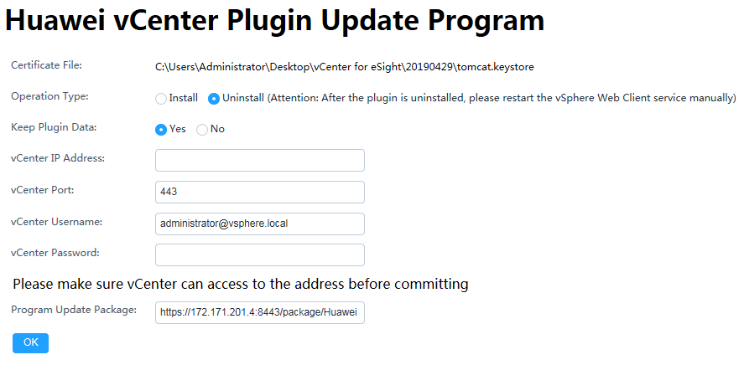

Set the following parameters, and click **OK**.

* **Operation type**: Select **Uninstall**.
* **vCenter IP address**: Enter the vCenter IP address where the plug-in is to be uninstalled.
* **vCenter port**: Enter the vCenter port number. The default value is **443**.
* **vCenter username**: Enter the vCenter administrator user name.
* vCenter password: Enter the vCenter administrator password.

In the CLI window, view the command output. If information shown in Figure 2-24 is displayed, the Huawei vCenter plug-in is successfully uninstalled.

Command output

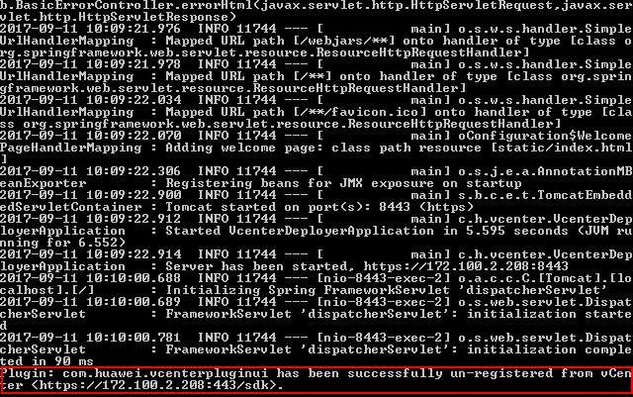

Restart the vCenter service.

* Restart vCenter in the Windows environment.
  1. Access the Windows CLI.
  2. Run the following command to stop the vCenter service:

"C:\Program Files\VMware\vCenter Server\bin\service-control.bat" --stop --all

* 1. Run the following command to start the vCenter service:

"C:\Program Files\VMware\vCenter Server\bin\service-control.bat" --start --all

* Restart vCenter in the Linux environment.
  1. Access the Linux CLI as user **root** by using the SSH tool.
  2. Run the following command to stop the vCenter service:

service-control --stop --all

* 1. Run the following command to start the vCenter service:

service-control --start --all

Open the browser on the local PC, enter **https://*vCenter IP address*** in the address box, and press **Enter**.

The vCenter login page is displayed.

Enter the vCenter user name and password, and click **Login**.

On the vCenter homepage, check whether the plug-in icon is deleted.

* If yes, no further action is required.
* If no, perform Step 14 to Step 15 to clear the browser cache and open the browser again.

Clear the browser cache.

Internet Explorer 11.0 is used as an example.

1. Select **Internet Options**.

The **Internet Options** dialog box is displayed.

1. Click **Delete**, as shown in Figure 2-25.

Internet Options

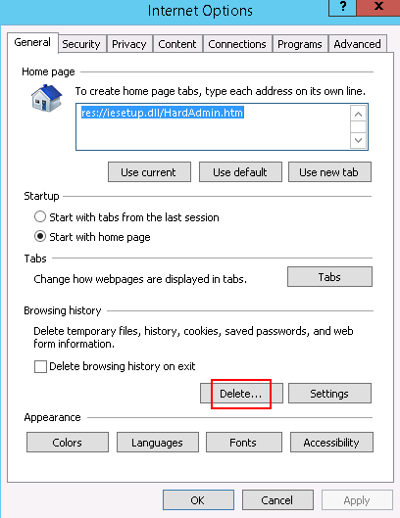

The **Delete Browsing History** dialog box is displayed.

1. Select the information shown in Figure 2-26, and click **Delete**.

Delete Browsing History

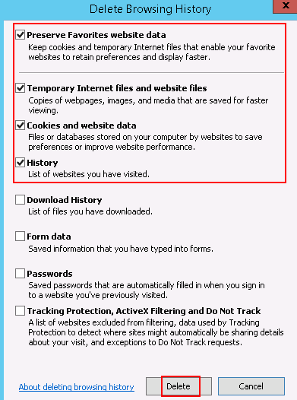

1. Click **Apply**, and click **OK.**

Open the browser again, log in to vCenter, and check whether the plug-in icon is deleted.

* If yes, no further action is required.
* If no, contact Huawei technical support.

----End

## Upgrading the Huawei vCenter Plug-in

Prerequisites

* You have installed JRE 1.8.0 or later on the Windows host.
* You have obtained the Huawei vCenter plug-in installation package [Huawei vCenter Plugin X.X.zip](https://github.com/Huawei/Server_Management_Plugin_vCenter/tree/master/releases) and the deployment software package Huawei vCenter Plugin Upgrade *X.X*.zip. Here, *X.X* indicates the plug-in version number, for example, **Huawei vCenter Plugin 1.0.zip**.
* You have prepared a host running a Windows OS for installing and running the deployment program package. The deployment program package supports only Windows OSs.



Ensure that the firewall of the Windows OS is disabled. Otherwise, the installation or uninstallation fails and the plug-in cannot be installed or uninstalled again.

Procedure

Uninstall the Huawei vCenter plug-in of the source version. For details, see 2.2 Uninstalling the Huawei vCenter Plug-in.

Install the Huawei vCenter plug-in of the target version. For details, see 2.1 Installing the Huawei vCenter Plug-In.

----End

# Operation and Maintenance

3.1 Configuring eSight

3.2 Managing Servers

3.3 Viewing the Huawei vCenter Plug-in Version

## Configuring eSight

### Adding an eSight

Set a whitelist.

By default, a whitelist of eSight northbound ports is configured. To add an eSight properly, you must add the IP address of the server where vCenter is located to the whitelist of eSight northbound ports.

1. Log in to the eSight WebUI.
2. Choose **System** > **Northbound Integration** > **Third-party System** > **Create**.

The **Third-party System** page is displayed, as shown in Figure 3-1.

Third-party System

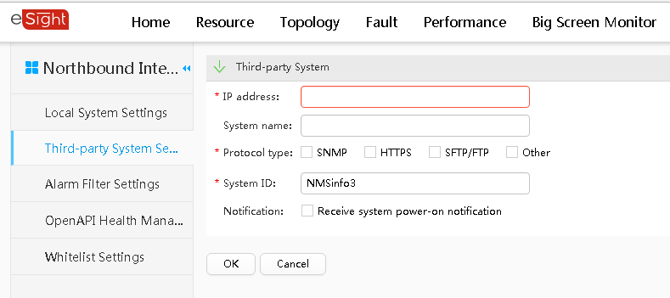

1. Set the following parameters:

* **IP address**: IP address of the vCenter server
* **Protocol type**: HTTPS
* **System ID**: Retain the default value or enter a new value. The value can be an IP address or a string of 1 to 64 characters, including digits (0-9), lowercase letters (a-z), uppercase letters (A-Z), and special characters @_- (), .^$~`!.

1. Click **OK**.

The IP address of the vCenter server is successfully added to the whitelist, as shown in Figure 3-2.

Whitelist configured successfully

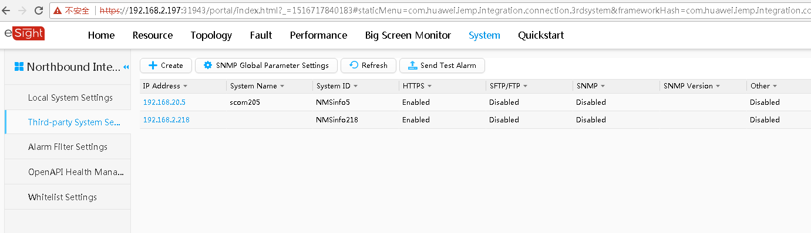

Obtain the eSight certificate.

1. Log in to the eSight background as an administrator.
2. Go to the *eSight installation directory\AppBase\etc\certificate\application\node* directory and obtain the **nodeKeyStore.jks** certificate file.

nodeKeyStore.jks

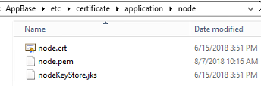

1. Copy the **nodeKeyStore.jks** certificate file to the local PC.

Upload the certificate to vCenter.

1. On the vCenter WebUI, choose **Home** > **Administration** > **eSight For vCenter**.

The **eSight For vCenter** page is displayed.

1. Select **eSight**.

The **eSight** page is displayed.

1. Click **Upload certificate**.

The **Upload certificate** dialog box is displayed, as shown in Figure 3-4.

Upload certificate

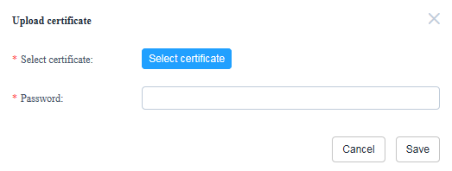

* Click **Select certificate**, and open the **nodeKeyStore.jks** certificate file.
* Set **Password** to **Changeme_123**.

1. Click **Save**. The **Prompt** dialog box is displayed.
2. Click **OK** to return to the **eSight** page.

On the vCenter WebUI, choose **Home** > **Administration** > **eSight For vCenter**.

The **eSight For vCenter** page is displayed.

Select **eSight**.

The **eSight** page is displayed.

Click **Add eSight**.

The **Add eSight** dialog box is displayed.

Set the following parameters, and click **Test**, as shown in Figure 3-5.

Add eSight

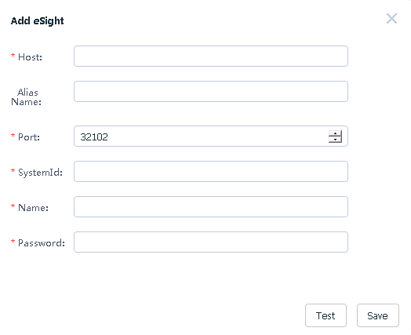

* **Host**: eSight IP address to be added
* **Alias**: name of the eSight to be added (Optional)
* **Port**: port number of the eSight to be added (default value: **32102**)
* **SystemId**: same as the value of System ID in Step 1.3
* **Name**: User name of the eSight OpenAPI to be added (default value: **openApiUser**)
* **Password**: password of the eSight OpenAPI to be added (default value: **Changeme_123**) To change the password, follow the instructions in 4.1 Connection Test Failed When Adding an eSight.

If the connection is normal, a message indicating connection success is displayed. If the connection fails, a message indicating failed connection is displayed. For the failure cause, see 4.1 Connection Test Failed When Adding an eSight.

After the connection is set up, click **Save** to save the eSight configuration.

The **Prompt** dialog box is displayed.

Click **OK**.

The eSight is added.

On the **eSight** page, view the added eSight, as shown in Figure 3-6.

eSight

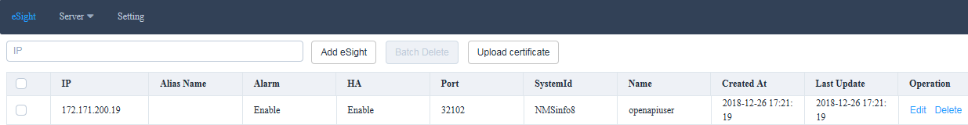

----End

### Editing an eSight

On the vCenter WebUI, choose **Home** > **Administration** > **eSight For vCenter**.

The **eSight For vCenter** page is displayed.

Select **eSight**.

The **eSight** page is displayed.

In the row of the eSight to be edited, click **Edit**.

The **Edit eSight** dialog box is displayed.

Set the following parameters, as shown in Figure 3-7.

Edit eSight

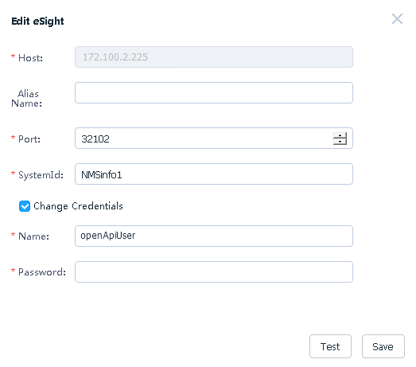

* **Alias Name**: name of the eSight
* **Port**: eSight port number
* **SystemId**: same as the value of System ID in Step 1.3
* **Change Credentials**: This parameter is deselected by default. You can select this parameter and change the eSight user name and password.
* **Name**: eSight user name
* **Password**: eSight password



After the eSight is connected, if the eSight port number, user name, or password is changed, you must synchronize the new port number, user name, or password to the Huawei vCenter plug-in; otherwise, server management of the Huawei vCenter plug-in will be affected.

Check whether **Change Credentials** is selected and the user name or password is changed.

* If yes, click **Test**. After the connection is set up, click **Save** to save the eSight configuration.
* If no, click **Save** to save the eSight configuration.

The **Prompt** dialog box is displayed.

Click **OK**.

The eSight editing is complete.

On the **eSight** page, view the modified eSight, as shown in Figure 3-8.

eSight



----End

### Deleting eSight

On the vCenter WebUI, choose **Home** > **Administration** > **eSight For vCenter**.

The **eSight For vCenter** page is displayed.

Select **eSight**.

The **eSight** page is displayed.

In the row of the eSight to be deleted, click **Delete**, as shown in Figure 3-9.

Deleting eSight



The **Prompt** dialog box is displayed.



To delete eSight systems in batches, select the eSight systems to be deleted, and click **Batch Delete**.

Click **OK**.

The eSight is deleted.

----End

## Managing Servers

### Viewing the Server List

On the vCenter WebUI, choose **Home** > **Administration** > **eSight For vCenter**.

The **eSight For vCenter** page is displayed.

Choose **Server** > **Server List**.

The server list page is displayed.

Select the eSight name and server type, and view the values of **IP Address**, **Name**, **Status**, and **Model**, as shown in Figure 3-10.

Server list

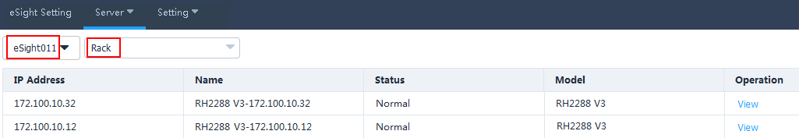

In the row of any server, click **View**.

View the basic information, online device status, and mainboard, CPU, memory, hard disk, PSU, fan, RAID, NIC, and PCIe information of the server, as shown in Figure 3-11.

Device status

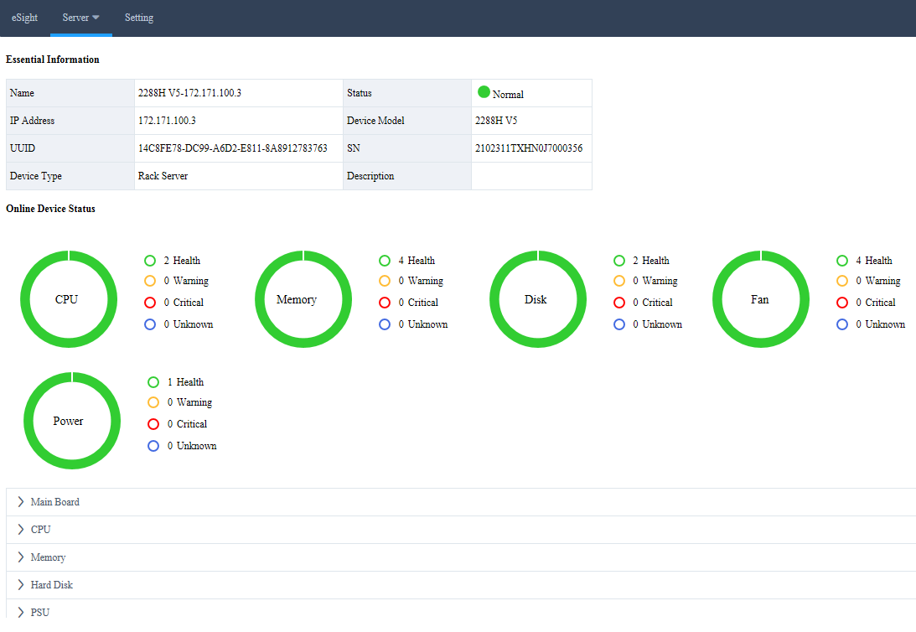

Click **Back**.

The server list page is displayed.

----End

### Deploying an OS

#### Adding a Software Source

Scenario

Adding a software source means adding an OS image file. When deploying an OS for a server, add an OS image file, an OS template, and then an OS deployment task.

Prerequisites

* The SFTP server for uploading the software source has been set up.
* The OS compatibility of the server has been confirmed using the [Huawei Server Compatibility Checker](http://support.huawei.com/onlinetoolsweb/ftca/indexEn?serise=2), and Note1 is present in the **Notes** column. For details, see 4.2 Failed to Deploy an OS.

Procedure

Upload the OS image file to be added to the default directory on the SFTP server.



* The size of the OS image file must not exceed 5 GB.
* The capacity of the eSight installation disk must be greater than 40 GB.

On the vCenter WebUI, choose **Home** > **Administration** > **eSight For vCenter**.

The **eSight For vCenter** page is displayed.

Choose **Server** > **Software Source Management**.

The **Software Source Management** page is displayed.

Click **Add**.

The **Add Software Source** dialog box is displayed.

Set the following parameters, and click **OK**, as shown in Figure 3-12.

Add Software Source

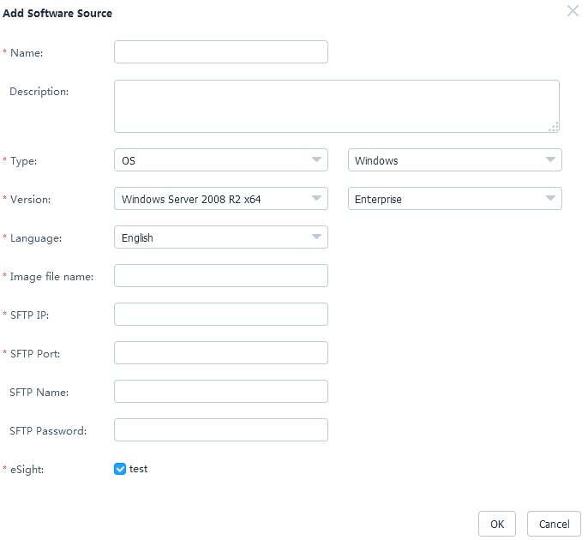

* **Name**: OS image file name
* **Description**: OS image file description (Optional)
* **Type**: OS type, which can be Windows, SUSE, Red Hat, CentOS, Ubuntu, or VMware ESXi
* **Version**: OS version. For details, see Table 3-1.
* **Language**: Select a language only when the OS type is Windows. Available options include **Chinese** and **English**.
* **Image file name**: name of image file on the SFTP server, for example, **rhel-server-7.2-x86_64-dvd.iso**
* **SFTP IP**: SFTP server IP address
* **SFTP Port**: SFTP server port number
* **SFTP Name**: SFTP server user name
* **SFTP Password**: SFTP server password
* **eSight**: name of the eSight for which you want to add an OS image file. You can select multiple eSight systems at the same time.

Supported software source versions

| Software Source Type | Version |
| --- | --- |
| Windows | Windows Server 2008 R2 x64 |
| Windows Server 2012 x64 |
| Windows Server 2012 R2 x64 |
| Windows Server 2016 x64 |
| SUSE | SUSE Linux Enterprise 11 SP4 x64 |
| SUSE Linux Enterprise 12 x64 |
| SUSE Linux Enterprise 12 SP1 x64 |
| SUSE Linux Enterprise 12 SP2 x64 |
| SUSE Linux Enterprise 12 SP3 x64 |
| Red Hat | Red Hat Linux Enterprise 6.7 x64 |
| Red Hat Linux Enterprise 6.8 x64 |
| Red Hat Linux Enterprise 6.9 x64 |
| Red Hat Linux Enterprise 7.0 x64 |
| Red Hat Linux Enterprise 7.1 x64 |
| Red Hat Linux Enterprise 7.2 x64 |
| Red Hat Linux Enterprise 7.3 x64 |
| Red Hat Linux Enterprise 7.4 x64 |
| Red Hat Linux Enterprise 7.5 x64 |
| CentOS | CentOS Linux Enterprise 6.7 x64 |
| CentOS Linux Enterprise 6.9 x64 |
| CentOS Linux Enterprise 7.0 x64 |
| CentOS Linux Enterprise 7.1 x64 |
| CentOS Linux Enterprise 7.2 x64 |
| CentOS Linux Enterprise 7.3 x64 |
| CentOS Linux Enterprise 7.4 x64 |
| CentOS Linux Enterprise 7.5 x64 |
| Ubuntu | Ubuntu Linux Enterprise 14.04 x64 |
| Ubuntu Linux Enterprise 16.04 x64 |
| VMWare ESXi | VMWare ESXi 5.5 x64 |
| VMWare ESXi 6.0 x64 |
| VMWare ESXi 6.5 x64 |
| VMWare ESXi 6.7 x64 |

The **Prompt** dialog box is displayed.

Click **OK**.

The software source is added.

On the **Software Source Management** page, view the added software sources, as shown in Figure 3-13.

Software Source Management

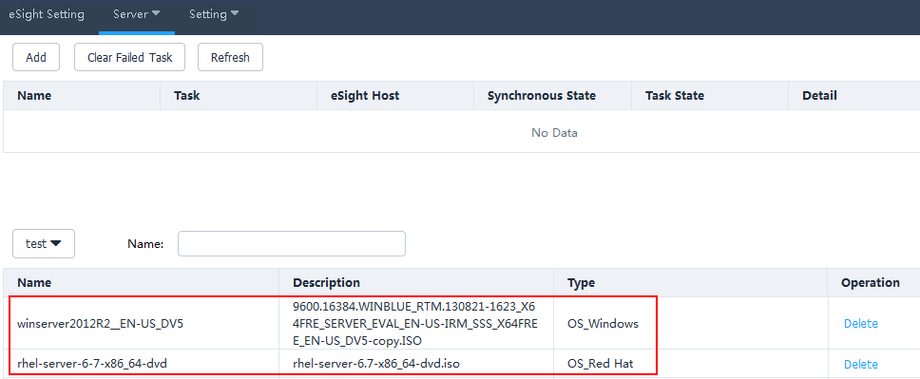

* Click **Refresh** to view the software source uploading progress.
* To delete a software source that fails to be uploaded, click **Clear Failed Task**. All software sources that fail to be uploaded will be deleted.
* To delete a software source that is successfully uploaded, click **Delete** in the row of the software source.

----End

#### Creating an OS Template

On the vCenter WebUI, choose **Home** > **Administration** > **eSight For vCenter**.

The **eSight For vCenter** page is displayed.

Choose **Server** > **Template Management**.

The **Template Management** page is displayed.

Click **Create Template**.

The **Create Template** page is displayed.

Set the following parameters, as shown in Figure 3-14.

Creating an OS template

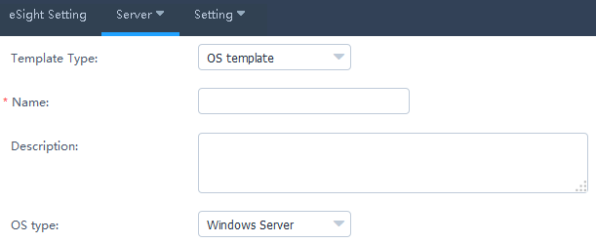

* **Template Type**: OS template
* **Name**: OS template name
* **Description**: OS template description (Optional)
* **OS type**: required OS type

In the **OS Settings** area, set the following parameters, as shown in Figure 3-15.

OS Settings

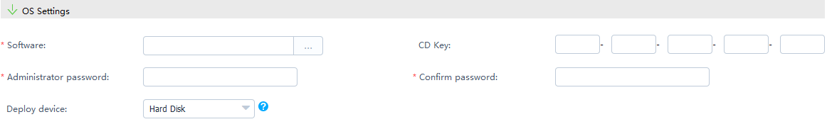

* **Software**: added software source
* **CD Key**: OS serial number. Set this parameter only when the OS type is Windows Server.
* **Administrator password**: OS administrator password
* **Confirm Password**: OS administrator password
* **Deploy device**: devices to be deployed

Set **Partition Settings** only when the OS type is Windows Server/SUSE Linux/Red Hat/CentOS, as shown in Figure 3-16.

Partition Settings

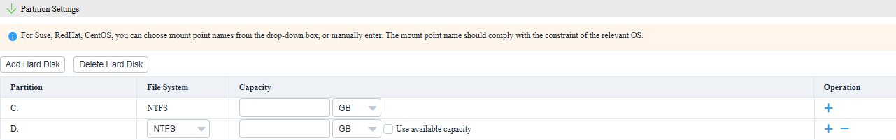

1. Click **Add Hard Disk**.
2. Set **File System**, enter the capacity of the new hard disk, and determine whether to use the remaining capacity based on the actual requirements.



* To add a partition for a hard disk, click .



* To delete a partition of a hard disk, click .



* To delete a hard disk, click **Delete Hard Disk**.

Click **OK**.

The **Prompt** dialog box is displayed.

Click **OK**.

The OS template is created.

On the **Template Management** page, view the created OS template, as shown in Figure 3-17.

Template Management

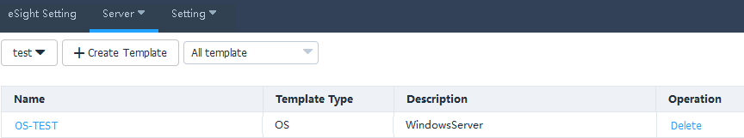

To delete a template, click **Delete** in the row of the template to be deleted.

----End

#### Creating a Template Task

Prerequisites

* Deploy the OS on V3 servers: You have obtained the ServiceCD tool (V137) from the **Software Download** tab on the [**FusionServer Tools**](https://support.huawei.com/enterprise/en/servers/fusionserver-tools-pid-21015513/software) page at [Huawei Enterprise](http://support.huawei.com/enterprise/en/index.html) support website, uploaded the .iso file of the decompressed package to **eSight installation directory\AppBase\var\iemp\data\ftp**, of eSight server, and changed the name of the .iso file to **FusionServer Tools-ServiceCD2.0-V110.iso**.
* Deploy the OS on V5 servers: You have obtained the Smart Provisioning (V116 or later) from the **Software Download** tab on the [**Smart Provisioning**](https://support.huawei.com/enterprise/en/servers/smart-provisioning-pid-23143793/software) page at [Huawei Enterprise](http://support.huawei.com/enterprise/en/index.html) support website, uploaded the .iso file of the decompressed package to **eSight installation directory\AppBase\var\iemp\data\ftp**, of eSight server, and changed the name of the .iso file to **SmartProvisioning.iso**.

Procedure

On the vCenter WebUI, choose **Home** > **Administration** > **eSight For vCenter**.

The **eSight For vCenter** page is displayed.

Choose **Server** > **Task Management**.

The **Task Management** page is displayed.

Click **Create Task**.

The page for adding a task is displayed.

Set the following parameters, and click **OK**, as shown in Figure 3-18.

Creating a task

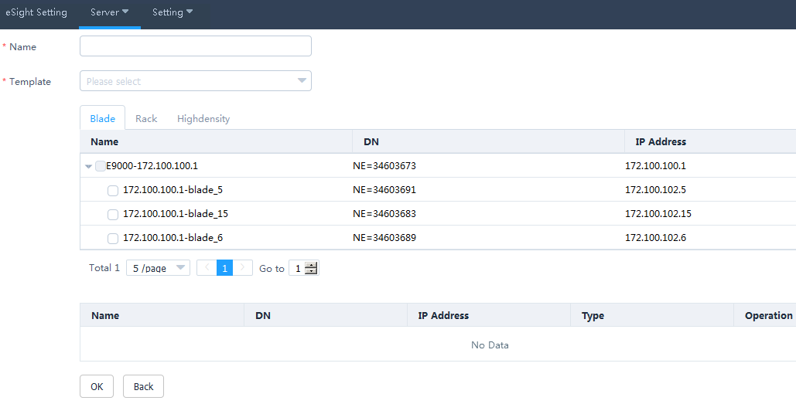

* **Name**: name of the task
* **Template**: name of the created template. Also select the server to which the template is to be added.

The **Prompt** dialog box is displayed.

Click **OK**.

The task is created.

On the **Task Management** page, view the created task, as shown in Figure 3-19.

Task Management

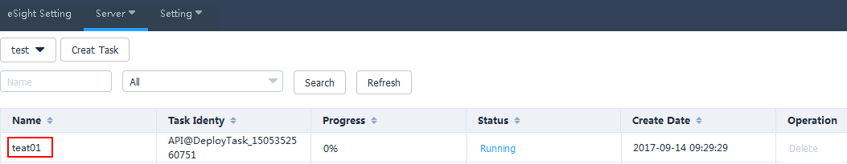

When the value of **Progress** changes to 100%, check the status value in **Status** to view the template task operation result, as shown in Figure 3-20.

Details about Deployed Devices

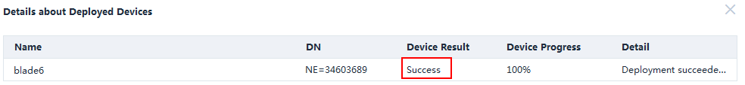

* Click **Refresh** to view the template task progress.
* To delete a template task, click **Delete** in the row of the template task to be deleted.

----End

### Managing Templates

#### Configuring Power Control

On the vCenter WebUI, choose **Home** > **Administration** > **eSight For vCenter**.

The **eSight For vCenter** page is displayed.

Choose **Server** > **Template Management**.

The **Template Management** page is displayed.

Click **Create Template**.

The page for creating a template is displayed.

Set the following parameters, and click **OK**, as shown in Figure 3-21.

Adding a power control template

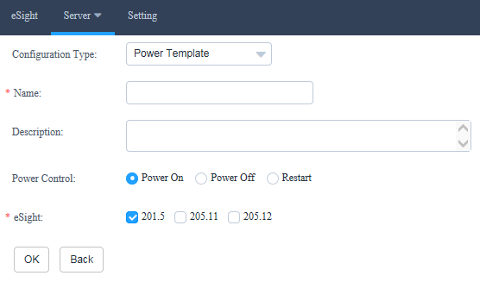

* **Configuration Type**: Select **Power Template**.
* **Name**: Set this parameter to a customized name. This parameter is used to identify the power control template.
* **Description**: (Optional) Set this parameter to customized description, which provides supplementary information for the power control template.
* **Power Control**: Select **Power on**, **Power off**, or **Restart**.
* **eSight**: Select the eSight based on the actual requirements. You can select multiple eSight systems.

The **Prompt** dialog box is displayed.

Click **OK**.

The power control template is created.

On the **Template Management** page, view the created power control template.



To delete a template, click **Delete** in the row of the template to be deleted.

Create a template task. For details, see 3.2.2.3 Creating a Template Task.

----End

#### Configuring the BIOS

On the vCenter WebUI, choose **Home** > **Administration** > **eSight For vCenter**.

The **eSight For vCenter** page is displayed.

Choose **Server** > **Template Management**.

The **Template Management** page is displayed.

Click **Create Template**.

The page for creating a template is displayed.

Set the following parameters, as shown in Figure 3-22.

Adding a BIOS template

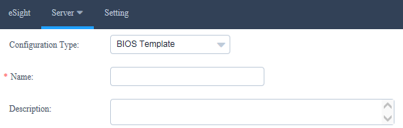

* **Configuration Type**: Select **BIOS Template**.
* **Name**: Set this parameter to a customized name. This parameter is used to identify the BIOS template.
* **Description**: (Optional) Set this parameter to customized description, which provides supplementary information for the BIOS template.

In the **Boot** area, use or to set the system boot sequence.



In the **Virtualization** area, set the parameters described in Table 3-2, as shown in Figure 3-23.

Virtualization



Parameters in the Virtualization area

| Parameter | Description |
| --- | --- |
| VT support | Enables or disables the hardware-assisted virtualization technology.   * **Enabled**: enables the hardware-assisted virtualization technology. * **Disabled**: disables the hardware-assisted virtualization technology. * **Default**: retains the default settings. |
| PCIe SR-IOV | Enables or disables the SR-IOV technology of the PCIe card.   * **Enabled**: enables the SR-IOV technology of the PCIe card. * **Disabled**: disables the SR-IOV technology of the PCIe card. * **Default**: retains the default settings. |

In the **Advanced Processor** area, set the parameters described in Table 3-3, as shown in Figure 3-24.

Advanced Processor

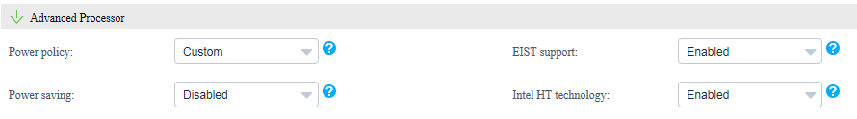

Parameters in the Advanced Processor area

| Parameter | Description |
| --- | --- |
| Power policy | Indicates the power policy.   * **Efficient**: indicates the mode of low performance and low power consumption. This mode can reduce the power consumption of the system. * **Performance**: indicates the mode of high performance and high power consumption. * **Custom**: indicates the mode that reduces the power consumption of most OSs and applications and minimizes the impact on performance. * **Default**: retains the default settings. |
| EIST support | Indicates the intelligent frequency control function.   * **Enabled**: enables the EIST function. * **Disabled**: disables the EIST function. * **Default**: retains the default settings. |
| Power saving | Indicates the CPU P State adjustment function.   * **Enabled**: enables the CPU P State adjustment function. * **Disabled**: disables the CPU P State adjustment function. * **Default**: retains the default settings. |
| Intel HT technology | Indicates the Intel Hyper Threading (HT) technology. This technology enhances CPU performance by increasing the number of CPU kernel threads.   * **Enabled**: enables the CPU HT function. * **Disabled**: disables the CPU HT function. * **Default**: retains the default settings. |

In the **IPMI** area, set the parameters described in Table 3-4, as shown in Figure 3-25.

IPMI



Parameters in the IPMI area

| Parameter | Description |
| --- | --- |
| Restore on AC Power Loss | Indicates the restoration mode used by the BMC after AC power-off.   * **Power OFF**: powers off the system. * **Last State**: restores the system to the last state. * **Power ON**: powers on the system. * **Default**: retains the default settings. |

Click **Advanced**.

The **Advanced Settings** dialog box is displayed.

In the **Boot** area, set the parameters described in Table 3-5, as shown in Figure 3-26.

Boot

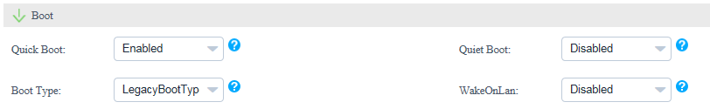

Parameters in the Boot area

| Parameter | Description |
| --- | --- |
| Quick Boot | Indicates the quick boot mode.   * **Enabled**: enables the quick boot mode. * **Disabled**: disables the quick boot mode. * **Default**: retains the default settings. |
| Quiet Boot | Indicates the quiet boot mode.   * **Enabled**: enables the quiet boot mode. * **Disabled**: disables the quiet boot mode. * **Default**: retains the default settings. |
| Boot Type | Indicates the system boot mode.   * **Dual Boot Type**: supports both the Legacy boot mode and the UEFI boot mode. * **Legacy Boot Type**: supports only the Legacy boot mode. * **UEFI Boot Type**: supports only the UEFI boot mode. * **Default**: retains the default settings. |
| WakeOnLan | Indicates the remote startup of a server when it receives a special data packet.   * **Enabled**: enables the Wake On Lan function. * **Disabled**: disables the Wake On Lan function. * **Default**: retains the default settings. |

In the **Virtualization** area, set the parameters described in Table 3-6, as shown in Figure 3-27.

Virtualization

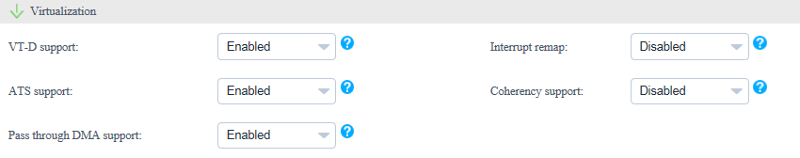

Parameters in the Virtualization area

| Parameter | Description |
| --- | --- |
| VT-D support | Indicates the direct I/O virtualization function.   * **Enabled**: enables the direct I/O virtualization function. * **Disabled**: disables the direct I/O virtualization function. * **Default**: retains the default settings. |
| Interrupt remap | Indicates the interrupt remapping function.   * **Enabled**: enables the interrupt remapping function. * **Disabled**: disables the interrupt remapping function. * **Default**: retains the default settings. |
| ATS support | Indicates the ATS function.   * **Enabled**: enables the ATS function. * **Disabled**: disables the ATS function. * **Default**: retains the default settings. |
| Coherency support | Indicates the Coherency Support function.   * **Enabled**: enables the Coherency Support function. * **Disabled**: disables the Coherency Support function. * **Default**: retains the default settings. |
| Pass through DMA support | Indicates the PassThrough DMA function.   * **Enabled**: enables the PassThrough DMA function. * **Disabled**: disables the PassThrough DMA function. * **Default**: retains the default settings. |

In the **Advanced Processor** area, set the parameters described in Table 3-7, as shown in Figure 3-28.

Advanced Processor

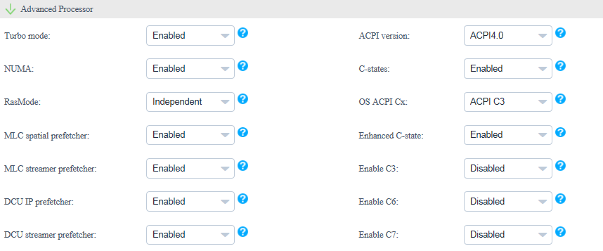

Parameters in the Advanced Processor area

| Parameter | Description |
| --- | --- |
| Turbo mode | Indicates the dynamic acceleration function.   * **Enabled**: enables the dynamic acceleration function. * **Disabled**: disables the dynamic acceleration function. * **Default**: retains the default settings. |
| ACPI version | Indicates the ACPI version.   * **ACPI1.0B**: ACPI1.0B version * **ACPI3.0**: ACPI3.0 version * **ACPI4.0**: ACPI4.0 version * **Default**: retains the default settings. |
| NUMA | Indicates the non-uniform memory access (NUMA) function.   * **Enabled**: enables the NUMA function. * **Disabled**: disables the NUMA function. * **Default**: retains the default settings. |
| C-states | Indicates the CPU C status control function.   * **Enabled**: enables the CPU C status control function. * **Disabled**: disables the CPU C status control function. * **Default**: retains the default settings. |
| RasMode | Indicates the memory RAS mode.   * Independent * Mirror * LockStep * RankSpare * LockStepAndRankSpare * Default |
| OS ACPI Cx | Indicates the Advanced Configuration and Power Interface (ACPI) C-state of the OS. The OS instructs a CPU to enter the C-state based on the ACPI C-state.   * ACPI C2 * ACPI C3 * Default |
| MLC spatial prefetcher | Indicates the Mid Level Cache (MLC) Spatial prefetcher function.   * **Enabled**: enables the MLC Spatial prefetcher function. * **Disabled**: disables the MLC Spatial prefetcher function. * **Default**: retains the default settings. |
| Enhanced C-state | Indicates the C-state function.   * **Enabled**: enables the C-state function. * **Disabled**: disables the C-state function. * **Default**: retains the default settings. |
| MLC streamer prefetcher | Indicates the MLC Streamer prefetcher function.   * **Enabled**: enables the MLC Streamer prefetcher function. * **Disabled**: disables the MLC Streamer prefetcher function. * **Default**: retains the default settings. |
| Enable C3 | Indicates the C3 function.   * **Enabled**: enables the C3 function. * **Disabled**: disables the C3 function. * **Default**: retains the default settings. |
| DCU IP prefetcher | Indicates the data cache unit (DCU) IP prefetcher function. This function determines whether to prefetch data based on historical records. This function is enabled by default. You can enable or disable this function based on the applications running on the server. This function can affect performance and shorten the data reading time.   * **Enabled**: enables the DCU IP prefetcher function. * **Disabled**: disables the DCU IP prefetcher function. * **Default**: retains the default settings. |
| Enable C6 | Indicates the C6 function.   * **Enabled**: enables the C6 function. * **Disabled**: disables the C6 function. * **Default**: retains the default settings. |
| DCU streamer prefetcher | Indicates the DCU streamer prefetcher function. This function can be used to preread CPU data. This function is enabled by default. You can enable or disable this function based on the applications running on the server. This function can affect performance and shorten the data reading time.   * **Enabled**: enables the DCU streamer prefetcher function. * **Disabled**: disables the DCU streamer prefetcher function. * **Default**: retains the default settings. |
| Enable C7 | Indicates the C7 function.   * **Enabled**: enables the C7 function. * **Disabled**: disables the C7 function. * **Default**: retains the default settings. |

In the **Console Serial Port** area, set the parameters described in Table 3-8, as shown in Figure 3-29.

Console Serial Port

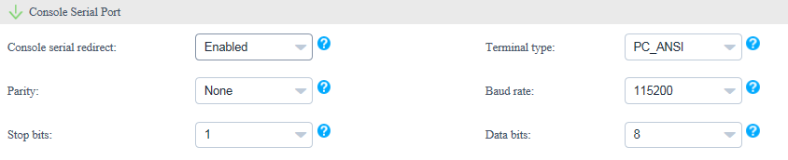

Parameters in the Console Serial Port area

| Parameter | Description |
| --- | --- |
| Console serial redirect | Indicates the serial port redirection function.   * **Enabled**: enables the serial port redirection function. * **Disabled**: disables the serial port redirection function. * **Default**: retains the default settings. |
| Terminal type | Indicates the terminal protocol.   * VT_100 * VT_100+ * VT_UTF8 * PC_ANSI * Default |
| Parity | Indicates the parity check function.   * **None**: indicates no parity check. * **Even**: indicates the even parity check. * **Odd**: indicates the odd parity check. * **Default**: retains the default settings. |
| Baud rate | Indicates the serial port redirection speed.   * 115200 * 57600 * 19200 * 9600 * Default |
| Stop bits | Indicates the stop bit for the serial port redirection function.   * 1 * 2 * Default |
| Data bits | Indicates the data bit length for the serial port redirection function.   * 7 * 8 * Default |

In the **IPMI** area, set the parameters described in Table 3-9, as shown in Figure 3-30.

IPMI

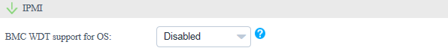

Parameters in the IPMI area

| Parameter | Description |
| --- | --- |
| BMC WDT support for OS | Indicates the watchdog during the OS startup process.   * **Enabled**: enables the watchdog during the OS startup process. * **Disabled**: disables the watchdog during the OS startup process. * **Default**: retains the default settings. |

Click **OK**.

Select the eSight to which the BIOS template is to be added, and click **OK**. (You can select multiple eSight systems.)

The **Prompt** dialog box is displayed.

Click **OK**.

The BIOS template is created.

On the **Template Management** page, view the created BIOS template.



To delete a template, click **Delete** in the row of the template to be deleted.

Create a template task. For details, see 3.2.2.3 Creating a Template Task.

----End

#### Configuring an HBA

On the vCenter WebUI, choose **Home** > **Administration** > **eSight For vCenter**.

The **eSight For vCenter** page is displayed.

Choose **Server** > **Template Management**.

The **Template Management** page is displayed.

Click **Create Template**.

The page for creating a template is displayed.

Set the following parameters, as shown in Figure 3-31.

Adding an HBA template

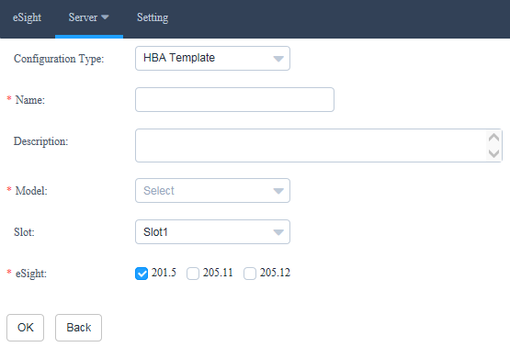

* **Configuration Type**: Select **HBA Template**.
* **Name**: Set this parameter to a customized name. This parameter is used to identify the HBA template.
* **Description**: (Optional) Set this parameter to customized description, which provides supplementary information for the HBA template.
* **Model**: Select the HBA model.
* **Slot**: Select the HBA slot number.
* **eSight**: Select the eSight based on the actual requirements. You can select multiple eSight systems.

In the port area, click **Advanced**.

The **Advanced** dialog box is displayed.

Set the following parameters, and click **OK**, as shown in Figure 3-32.

Advanced

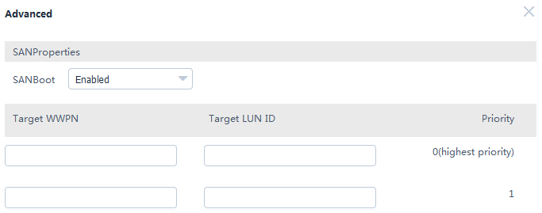

* **SAN boot**: Select **Enabled** or **Disabled**.
* **Target WWPN**: This parameter needs to be set only when **SAN boot** is set to **Enabled**.
* **Target LUN ID**: This parameter needs to be set only when **SAN boot** is set to **Enabled**.
* **Target WWNN**: This parameter needs to be set only when **SAN boot** is set to **Enabled** and **Adapter Model** is set to **QLE2560** or **QLE2562**.

Click **OK**.

The **Prompt** dialog box is displayed.

Click **OK**.

The HBA template is created.

On the **Template Management** page, view the created HBA template.



To delete a template, click **Delete** in the row of the template to be deleted.

Create a template task. For details, see 3.2.2.3 Creating a Template Task.

----End

#### Configuring RAID

On the vCenter WebUI, choose **Home** > **Administration** > **eSight For vCenter**.

The **eSight For vCenter** page is displayed.

Choose **Server** > **Template Management**.

The **Template Management** page is displayed.

Click **Create Template**.

The page for creating a template is displayed.

Set the following parameters, as shown in Figure 3-33.

Adding a RAID template

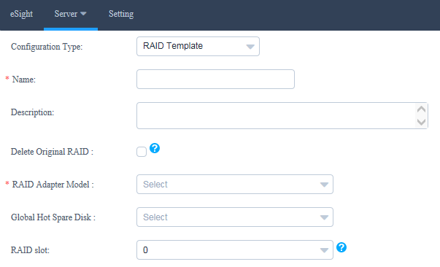

* **Configuration Type**: Select **RAID Template**.
* **Name**: Set this parameter to a customized name. This parameter is used to identify the RAID template.
* **Description**: (Optional) Set this parameter to customized description, which provides supplementary information for the RAID template.
* **Delete Original RAID**: This parameter is deselected by default. Determine whether to select this parameter based on the actual situation.
* **RAID Adapter Model**: Select the model of the RAID adapter to be configured.
* **Global Hot Spare Disk**: (Optional) This parameter is not set by default. Select the slot number of the hard disk to be set to a global hot spare disk. You can select multiple slot numbers.
* **RAID slot**: Select the slot number of the RAID controller card.

In the **RAID Group** area, click **Create**.

The **Create RAID Group** dialog box is displayed.

Set the following parameters, and click **OK**, as shown in Figure 3-34.

Create RAID Group

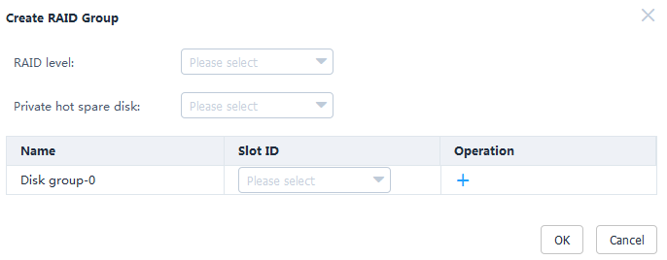

* **RAID level**: Select the RAID level to be configured.
* **Private hot spare disk**: (Optional) This parameter is not set by default. Select the slot number of the hard disk to be set to a private hot spare disk. You can select multiple slot numbers.



* Private hot spare disks cannot be configured for RAID 0.
* Private hot spare disks cannot be configured for LSI SAS2308, LSI SAS3008, and SAS3004.
* **Disk group-0**: Select the slot number of the hard disk to be added to the hard disk group.



Only one disk group can be created for RAID 0, RAID 1, RAID 5, RAID 6, and RAID 1E.

(Optional) Retain the default value **0** for **Start LUN ID**.

Click **OK**.

The **Prompt** dialog box is displayed.

Click **OK**.

The RAID template is created.

On the **Template Management** page, view the created RAID template.



To delete a template, click **Delete** in the row of the template to be deleted.

Create a template task. For details, see 3.2.2.3 Creating a Template Task.

----End

#### Configuring a CNA

On the vCenter WebUI, choose **Home** > **Administration** > **eSight For vCenter**.

The **eSight For vCenter** page is displayed.

Choose **Server** > **Template Management**.

The **Template Management** page is displayed.

Click **Create Template**.

The page for creating a template is displayed.

Set the following parameters, as shown in Figure 3-35.

Adding a CNA template

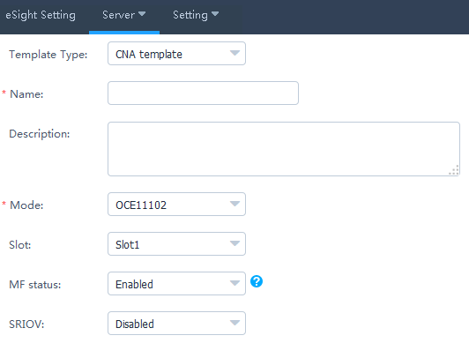

* **Template Type**: Select **CNA template**.
* **Name**: Set this parameter to a customized name. This parameter is used to identify the CNA template.
* **Description**: (Optional) Set this parameter to customized description, which provides supplementary information for the CNA template.
* **Mode**: Select the CNA model.
* **Slot**: (Optional) Select the CNA slot number.
* **MF status**: (Optional) This parameter needs to be set only when **Mode** is set to **OCE11102**, **MZ510**, or **MZ512**. Determine whether to enable MF based on the actual situation.
* **SRIOV**: (Optional) This parameter needs to be set only when **Mode** is set to **OCE11102**, **MZ510**, or **MZ512**. Determine whether to enable SRIOV based on the actual situation.



MF and SRIOV cannot be enabled at the same time.

Check whether **Mode** is set to **MZ910**.

* If yes, perform Step 6 and Step 7.
* If no, go to Step 8.

In the port area, click **Advanced**.

The **Advanced** dialog box is displayed.

Enable or disable **PXE boot**, and click **OK**.

Then go to Step 11.

In the port area, set the parameters described in Table 3-10.

Port0

| Parameter | Description |
| --- | --- |
| PF type | * NIC * iSCSI * FCoE   NOTE  **iSCSI** and **FCoE** are available only for PF1. |
| PF VLAN ID | This parameter needs to be set if **PF type** is set to **NIC**. Enter a VLAN ID based on the actual situation. |

In the port area, click **Advanced**.

The **Advanced** dialog box is displayed.

Set the parameters described in Table 3-11, as shown in Figure 3-36.

Advanced

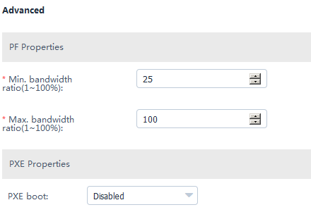

Parameters in the Advanced dialog box

| Parameter | Description |
| --- | --- |
| Min. bandwidth ratio | Indicates the minimum bandwidth ratio of a single virtual network port. |
| Max. bandwidth ratio | Indicates the maximum bandwidth ratio of a single virtual network port. |
| PXE boot | This parameter can be set to **Enabled** or **Disabled**. |

Click **OK**.

The **Prompt** dialog box is displayed.

Click **OK**.

The CNA template is created.

On the **Template Management** page, view the created CNA template.



To delete a template, click **Delete** in the row of the template to be deleted.

Create a template task. For details, see 3.2.2.3 Creating a Template Task.

----End

#### Configuring the iBMC

On the vCenter WebUI, choose **Home** > **Administration** > **eSight For vCenter**.

The **eSight For vCenter** page is displayed.

Choose **Server** > **Template Management**.

The **Template Management** page is displayed.

Click **Create Template**.

The page for creating a template is displayed.

Set the following parameters, as shown in Figure 3-37.

Adding an iBMC template

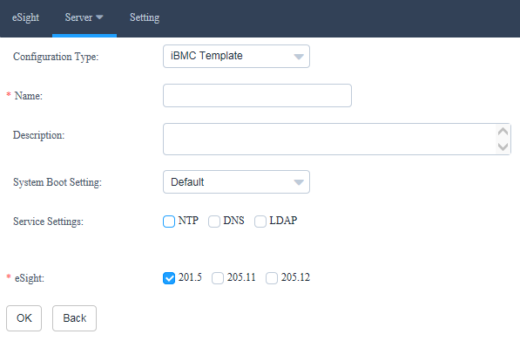

* **Configuration Type**: Select **iBMC template**.
* **Name**: Set this parameter to a customized name. This parameter is used to identify the iBMC template.
* **Description**: (Optional) Set this parameter to customized description, which provides supplementary information for the iBMC template.
* **System Boot Setting**: Select a system boot option based on the actual situation.
* **Service Settings**: Select a service setting option based on the actual situation. You can select multiple options. After **NTP**, **DNS**, or **LDAP** is selected, the related parameters need to be set.
* **eSight**: Select the eSight based on the actual requirements. You can select multiple eSight systems.

In the **NTP** area, set the parameters described in Table 3-12, as shown in Figure 3-38.

NTP

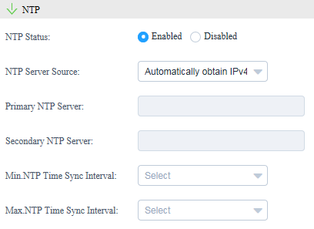

Parameters in the NTP area

| Parameter | Description |
| --- | --- |
| NTP Status | Enable or disable NTP.   * Enabled * Disabled |
| NTP Server Source | Select the NTP server source obtaining mode.   * Automatically obtain IPv4 * Automatically obtain IPv6 * Manually obtain |
| Primary NTP Server | (Optional) Enter the preferred NTP server IP address only when the NTP server source is obtained manually. |
| Secondary NTP Server | (Optional) Enter the alternate NTP server IP address only when the NTP server source is obtained manually. |
| Min.NTP Time Sync Interval | Select the minimum interval as required. |
| Max.NTP Time Sync Interval | Select the maximum interval as required. |

In the **DNS** area, set the parameters described in Table 3-13.

Parameters in the DNS area

| Parameter | Description |
| --- | --- |
| DNS Source | Select the DNS obtaining mode.   * Automatically Obtain * Manually Set |
| Domain Name | (Optional) Set the domain name only when the DNS is set manually. |
| Primary DNS Server | (Optional) Set the preferred DNS server IP address only when the DNS is set manually. |
| Secondary DNS Server | (Optional) Set the alternate DNS server IP address only when the DNS is set manually. |

In the **LDAP** area, set the parameters described in Table 3-14, as shown in Figure 3-39.

LDAP

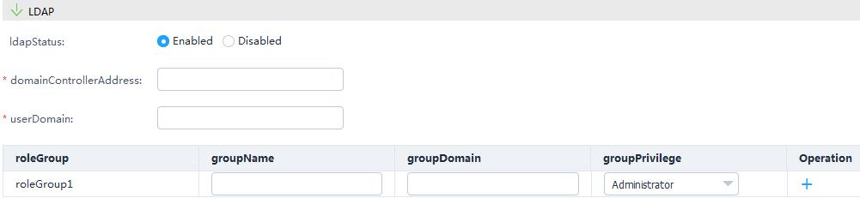

Parameters in the LDAP area

| Parameter | Description |
| --- | --- |
| LDAP Status | Select the LDAP status.   * Enabled * Disabled |
| Domain Controller Address | (Optional) Set the domain controller address only when LDAP is enabled. |
| User Domain | (Optional) Set the user domain only when LDAP is enabled. |
| Role Group | (Optional) Set the group name, group domain, and group privilege only when LDAP is enabled.  NOTE  You need to configure at least one role group. A maximum of five role groups can be configured. |

Click **OK**.

The **Prompt** dialog box is displayed.

Click **OK**.

The iBMC template is created.

On the **Template Management** page, view the created iBMC template.



To delete a template, click **Delete** in the row of the template to be deleted.

Create a template task. For details, see 3.2.2.3 Creating a Template Task.

----End

### Upgrading the Firmware and Driver

#### Uploading an Upgrade Package

Prerequisites

The SFTP server for uploading the upgrade package has been set up.

Procedure

Upload an upgrade package and the corresponding digital signature file to the SFTP server.

On the vCenter WebUI, choose **Home** > **Administration** > **eSight For vCenter**.

The **eSight For vCenter** page is displayed.

Choose **Server** > **Firmware Upload**.

The **Firmware Upload** page is displayed.

Click **Add**.

The page for adding a file is displayed.

Set the following parameters, and click **OK**, as shown in Figure 3-40.

Uploading an upgrade package

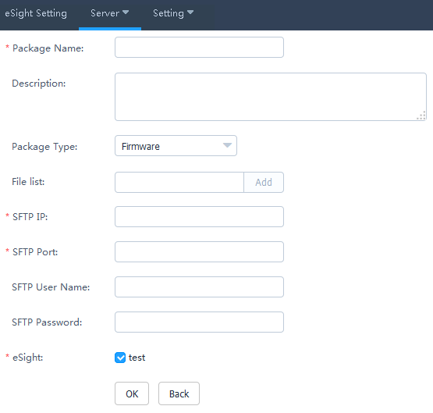

* **Package Name**: upgrade package name
* **Description**: upgrade package description
* Package Type: type of the upgrade package, which can be **Firmware**, **Driver**, or **Bundle**.
* **File list**: upgrade package file and digital signature file. Enter the upgrade package name, and click **Add**. Then enter the digital signature file name, and click **Add**.



For firmware and driver packages, ZIP and digital signature certificates must be uploaded. For bundle packages, only ZIP packages need to be uploaded.

* **SFTP IP**: SFTP server IP address
* **SFTP Port**: SFTP server port number
* **SFTP Name**: SFTP server user name
* **SFTP Password**: SFTP server password
* **eSight**: name of the eSight for which you want to upload an upgrade package. You can select multiple eSight systems at the same time.

The **Prompt** dialog box is displayed.

Click **OK**.

The firmware upload task is created.

On the **Firmware Upload** page, view the created firmware uploading task, as shown in Figure 3-41.

Firmware Upload

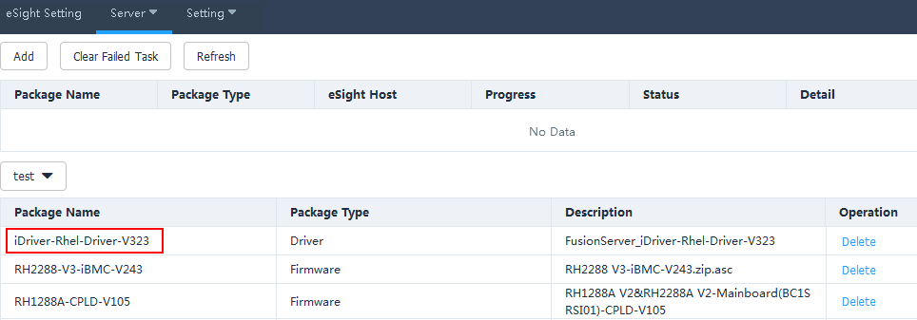

* Click **Refresh** to view the firmware uploading progress.
* When the value of **Progress** changes to 100%, check the status value in **Status** to view the package uploading result.
* To delete an upgrade package that fails to be uploaded, click **Clear Failed Task**. All upgrade packages that fail to be uploaded will be deleted.
* To delete an upgrade package that is successfully uploaded, click **Delete** in the row of the upgrade package.

----End

#### Upgrading the Firmware and Driver

Prerequisites

You have installed iBMA 2.0.0 or later on the OS of the managed server. You can log in to [Huawei Enterprise](http://support.huawei.com/enterprise/en/index.html) support website and choose **Support > Servers > Server Management Software > iBMA** to obtain the software.

Procedure

On the vCenter WebUI, choose **Home** > **Administration** > **eSight For vCenter**.

The **eSight For vCenter** page is displayed.

Choose **Server** > **Firmware Upgrade**.

The **Firmware Upgrade** page is displayed.

Click **Create Task**.

The page for adding a task is displayed.

Set the following parameters, and click **OK**, as shown in Figure 3-42.

Creating an upgrade task

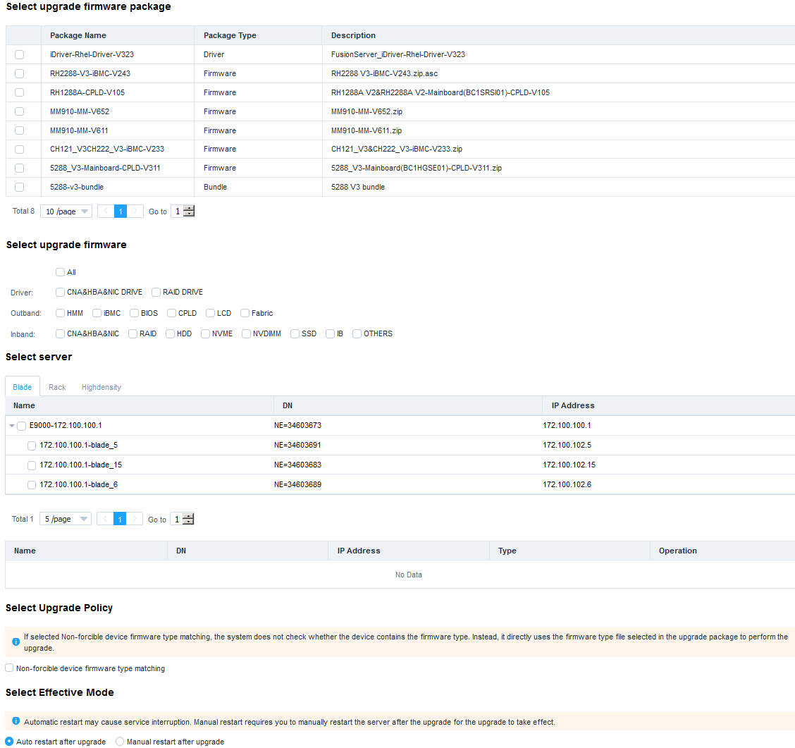

* **Select upgrade firmware package**: name of the firmware package to be upgraded
* **Select upgrade firmware**: firmware to be upgraded
* **Select server**: server to be upgraded
* **Select Upgrade Policy**: **Non-forcible device firmware type matching** is deselected by default.
* **Select Effective Mode**: **Auto restart after upgrade** is selected by default.

The **Prompt** dialog box is displayed.

Click **OK**.

The upgrade task is created.

On the **Firmware Upgrade** page, view the created firmware upgrade task, as shown in Figure 3-43.

Firmware Upgrade

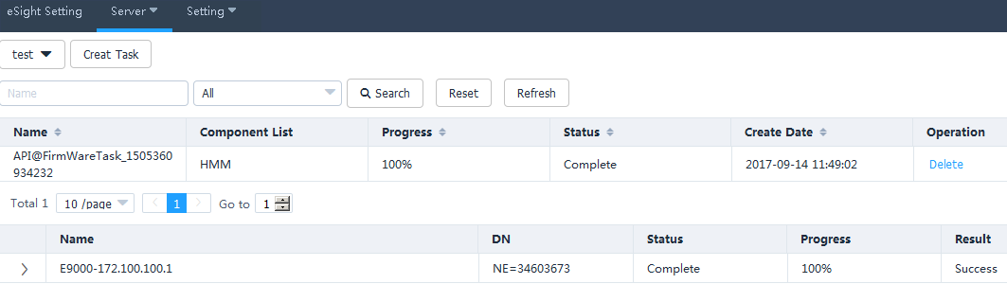

* Click **Refresh** to view the firmware and driver upgrade progress.
* When the value of **Progress** changes to 100%, check the status value in **Status** to view the firmware and driver upgrade result.
* To delete a firmware and driver upgrade task, click **Delete** in the row of the firmware and driver upgrade task.

----End

### Registering, Configuring, and Using Proactive HA

#### Registering the HA Provider



* The ESXi system has been installed on the target server, and the ESXi system has been added to the vCenter cluster. For details, see 4.4 How to Add a Server ESXi System to a vCenter Cluster.
* The target server has been added to eSight, and eSight has been added to the Huawei vCenter plug-in.
* After the HA Provider is registered, if you need to add another host to the cluster, you need to add it to **Datacenter**, register the HA Provider again, and move the host to the cluster.

On the vCenter WebUI, choose **Home** > **Administration** > **eSight For vCenter**.

The **eSight For vCenter** page is displayed, as shown in Figure 3-44.

Huawei vCenter plug-in

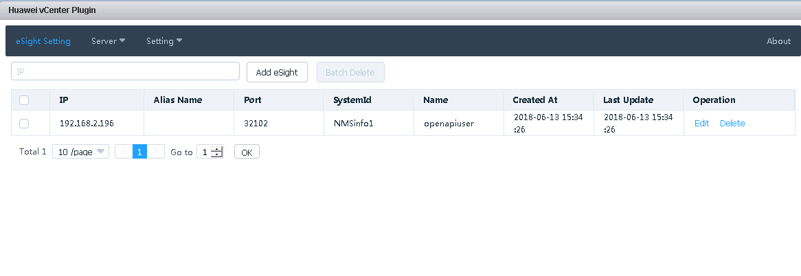

Choose **Setting** > **HA Setting**.

The HA setting page is displayed, as shown in Figure 3-45.

Registering the HA Provider

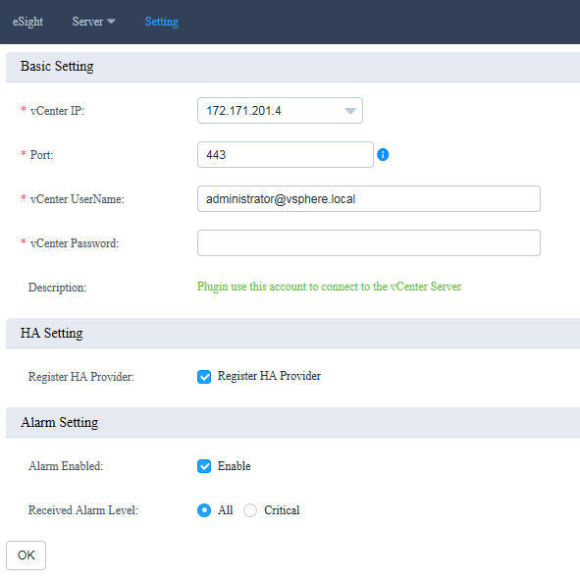

Select **Register HA Provider**, enter the IP address, port, user name, and password of the current vCenter, and click **OK**.

The HA Provider registration starts. After the registration is successful, a dialog box is displayed, as shown in Figure 3-46.

Successful registration

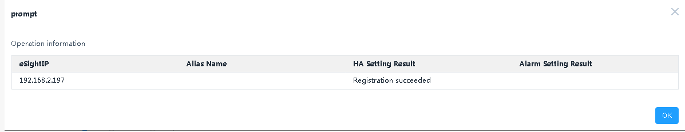

Click **OK**.

The HA Provider is registered.

----End

#### Configuring Proactive HA

On the vCenter WebUI, choose **Home** > **Inventories** > **Hosts and Clusters**.

The **Hosts and Clusters** page is displayed.

Click the cluster where the target host is located, and click **Configure**.

The page for configuring Proactive HA is displayed, as shown in Figure 3-47.

Configuring Proactive HA

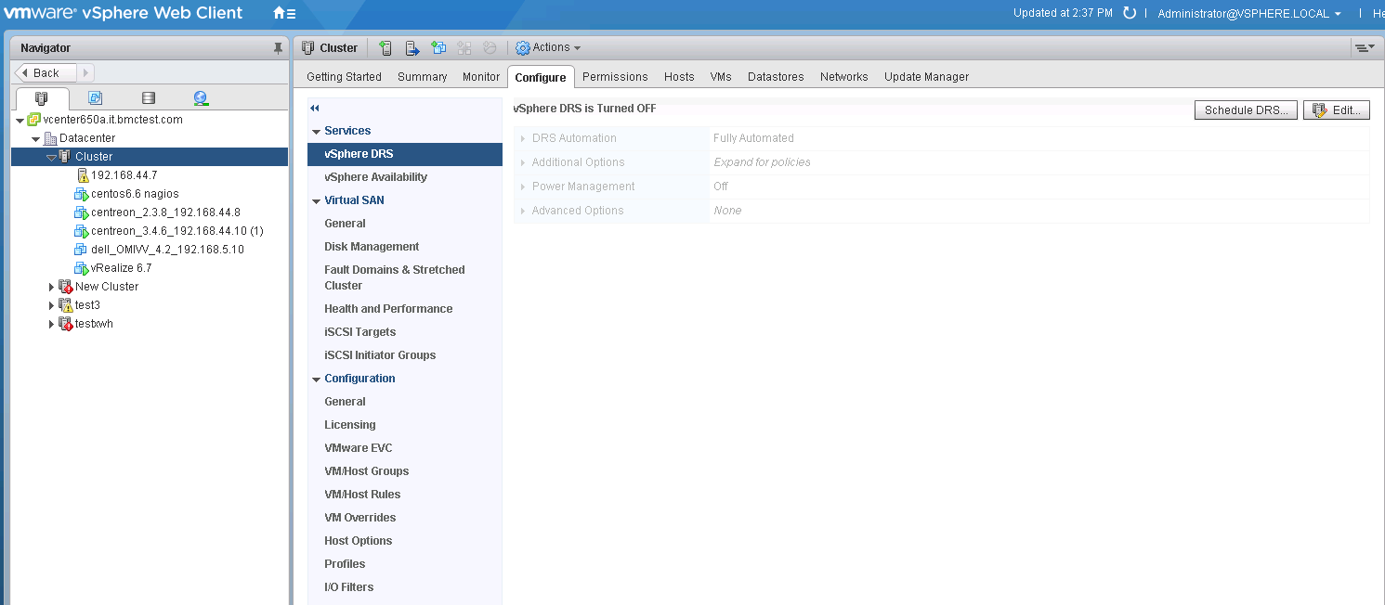

Click **Edit** in the upper right corner.

The **Edit Cluster Setting** page is displayed, as shown in Figure 3-48.

Edit Cluster Setting

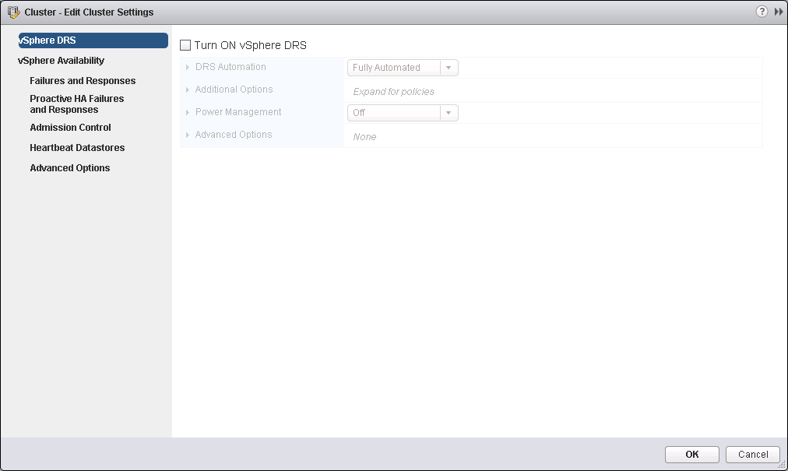

Select **Turn ON vSphere DRS**.

Click **vSphere Availability**.

The **vSphere Availability** page is displayed, as shown in Figure 3-49.

vSphere Availability

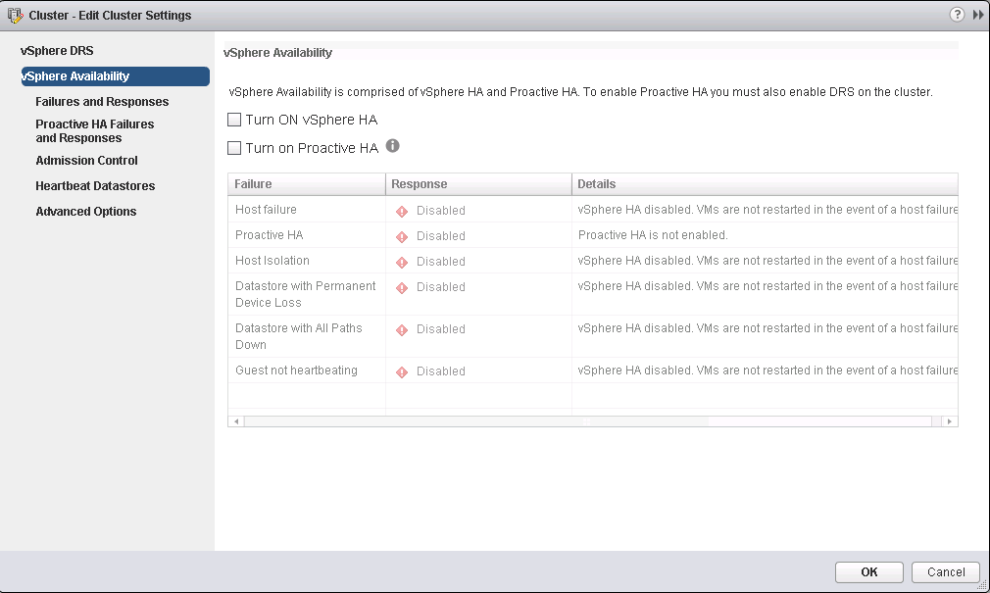

Select **Turn ON vSphere HA** and **Turn on Proactive HA**.

Click **Failures and Responses**.

The **Failures and Responses** page is displayed, as shown in Figure 3-50.

Failures and Responses

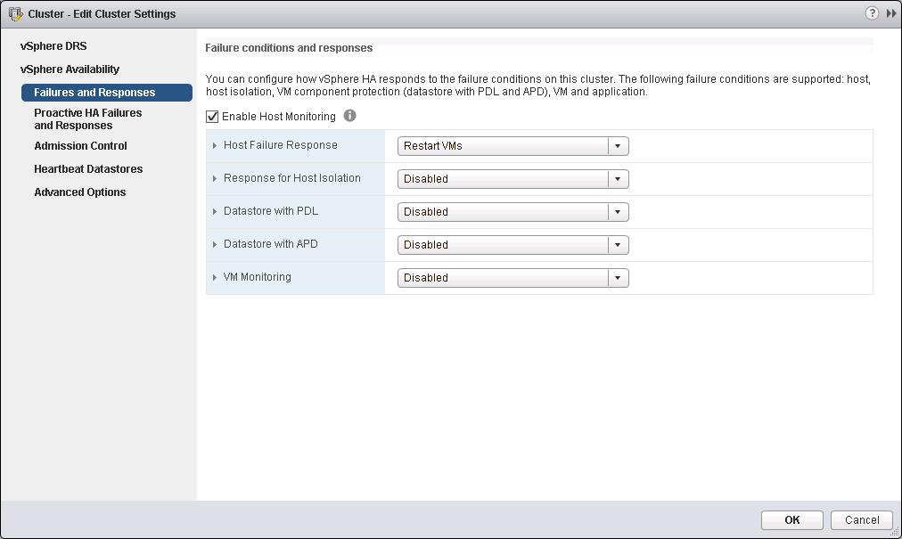

Select **Enable Host Monitoring**.

Click **Proactive HA Failures and Responses**.

The **Proactive HA Failures and Responses** page is displayed, as shown in Figure 3-51.

Proactive HA Failures and Responses

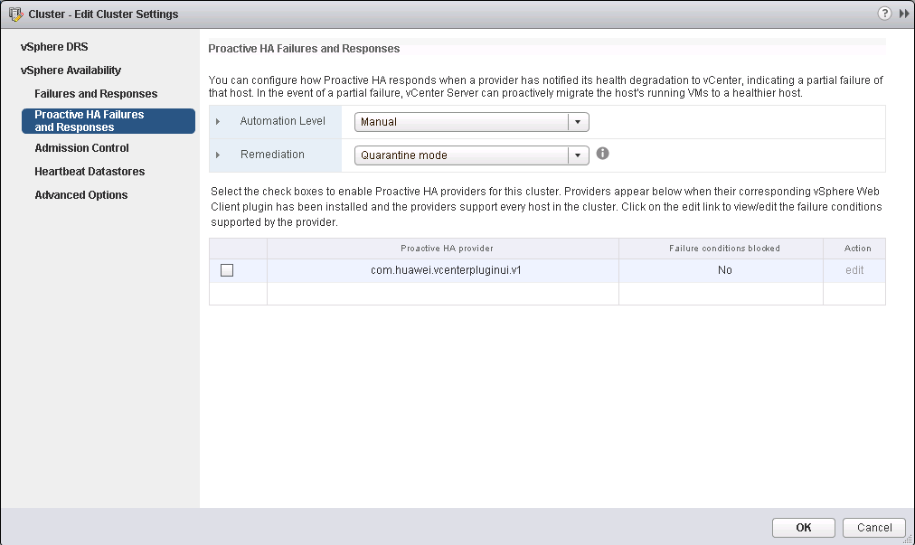

In the **Proactive HA provider** table, select the provider program **com.huawei.vcenterpluginui.v1** provided by the Huawei vCenter plug-in, and click **OK**.

Proactive HA is configured.

----End

#### Using Proactive HA

On the vCenter WebUI, choose **Home** > **Inventories** > **Hosts and Clusters**.

The **Hosts and Clusters** page is displayed.

Choose **Datacenter** > **Cluster** > *Host*.

The host page is displayed, as shown in Figure 3-52.

Host

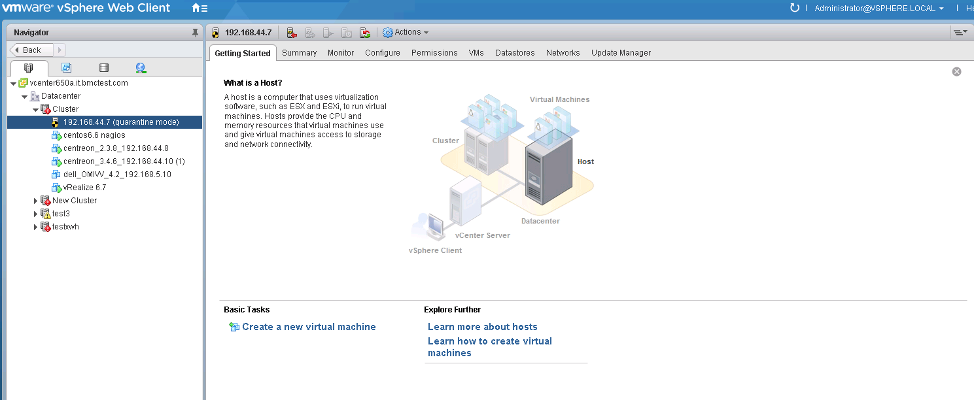

Choose **Monitor** > **Tasks & Events** > **Events**.

The event page of the server is displayed, as shown in Figure 3-53. You can view the alarms pushed by HA Provider. The alarm description is started with the HA Provider name.

Events

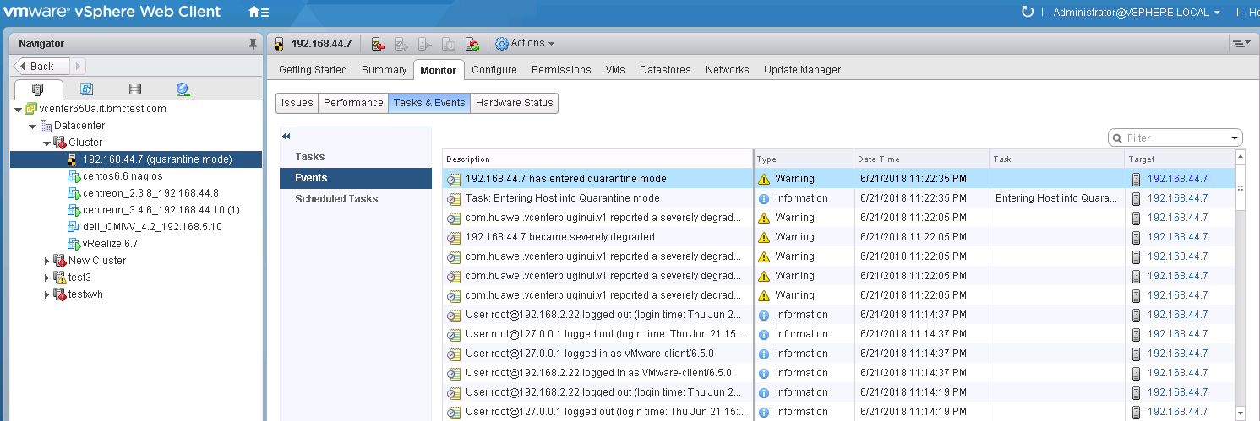

If **Automation Level** is set to **Automated** and **Remediation** is set to **Quarantine mode** in 3.2.5.2 Configuring Proactive HA, as shown in Figure 3-54, when the alarms pushed by HA Provider are severely degraded, vCenter will isolate the host.

Configuring Proactive HA

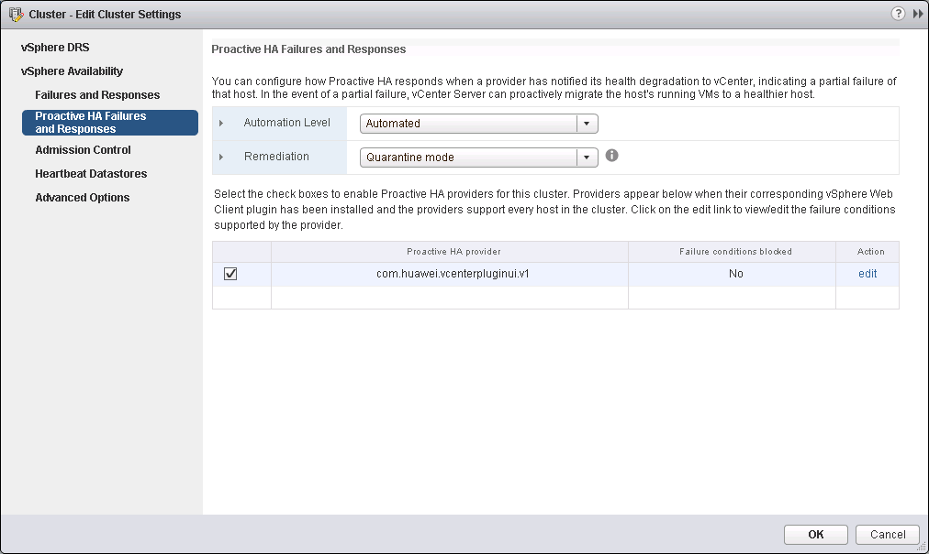

----End

### Receiving and Viewing Server Alarms

On the vCenter WebUI, choose **Home** > **Administration** > **eSight For vCenter**.

The **eSight For vCenter** page is displayed.

Choose **Setting** > **Basic Setting**.

The Basic Setting page is displayed, as shown in Figure 3-55.

Enter basic information.

Basic Setting



**Basic Setting**

* **vCenter IP:** Enter the vCenter IP address.
* **Port**: Enter the vCenter port number. The default value is **443**.
* **vCenter UserName:** Enter the vCenter administrator user name.
* **vCenter Password:** Enter the vCenter administrator password.

**Alarm Setting**

* **Alarm Enabled:** Determine whether to receive alarms.
* **Received Alarm Level:**
* **All:** Receive all events and alarms.
* **Critical:** Receive critical events and alarms.

Click **OK**. After information indicating that the configuration is successful is diaplayed, go to Step 4.

On the vCenter WebUI, choose **Home** > **Inventories** > **Hosts and Clusters**.

The **Hosts and Clusters** page is displayed.

Click the cluster where the target host is located to view events and alarms.

* Choose **Monitor** > **Task & Events** to view server events.

Events

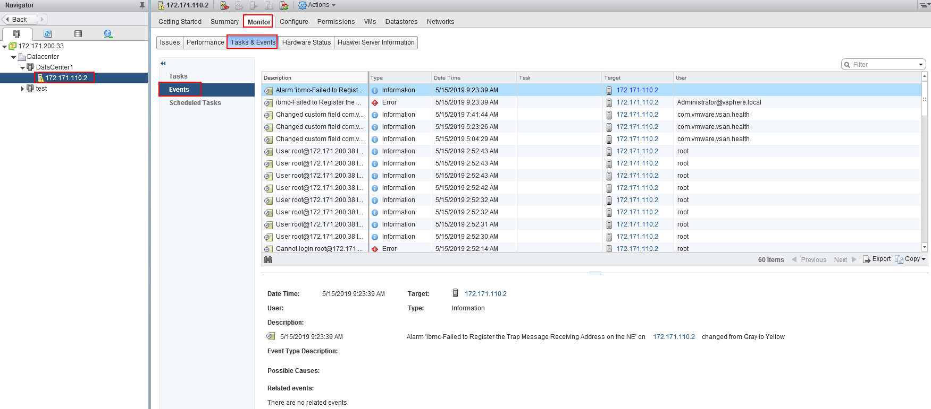

* Choose **Monitor** > **Events**.

The problem description, alarm type, triggering time, and status information are displayed in the list.

Events

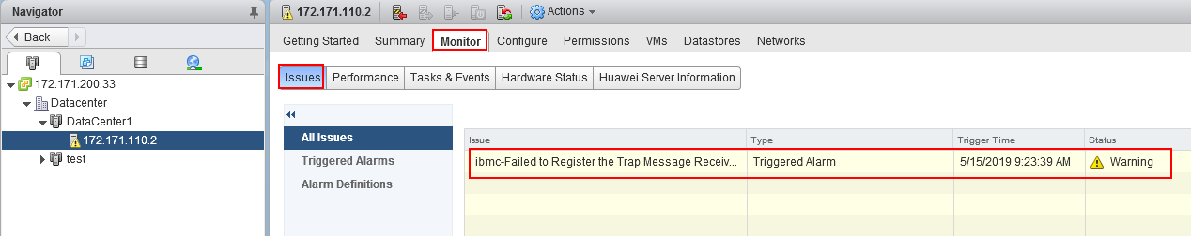

Click **Triggered Alarms**, and click the name of an alarm in the right list to view detailed alarm information.

Triggered Alarms

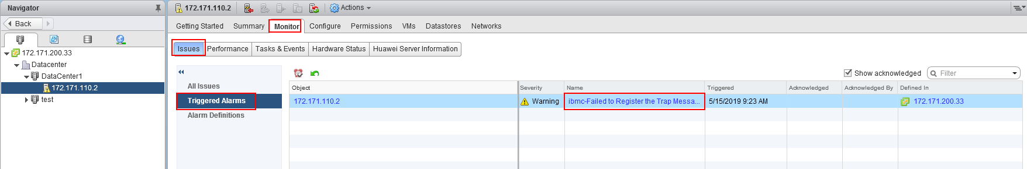

Alarms Definitions

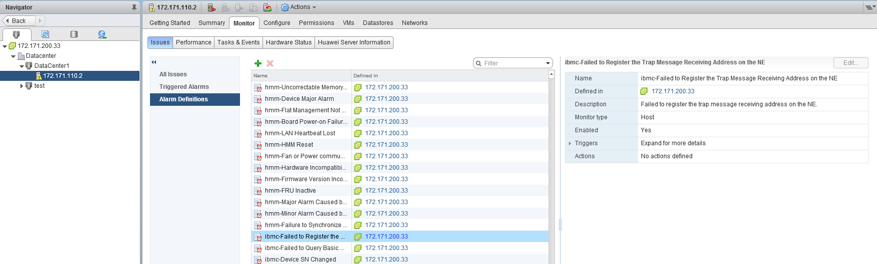

* Choose **Monitor** > **Huawei Server Information** to view the name, iBMC IP, eSight IP and health status of the server for which the alarm is generated.

Huawei Server Information

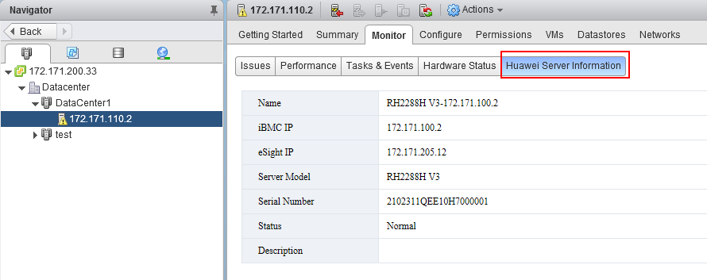

----End

## Viewing the Huawei vCenter Plug-in Version

On the vCenter WebUI, choose **Home** > **Administration** > **eSight For vCenter**.

The **eSight For vCenter** page is displayed.

Click **About**.

View the Huawei vCenter plug-in version, as shown in Figure 3-61.

Huawei vCenter plug-in version



----End

# FAQs

4.1 Connection Test Failed When Adding an eSight

4.2 Failed to Deploy an OS

4.3 Failed to Upload an Upgrade Package

4.4 How to Add a Server ESXi System to a vCenter Cluster

4.5 Icon of the eSight For vCenter Not Displayed in the vCenter Home Page

4.6 Failed to Start the Huawei vCenter Plug-in Installation Program and Deployment Program

4.7 On the Huawei vCenter Plugin Update Program Page, "Please put zip file and refresh the page" Is Displayed

4.8 RAID Controller Card Slot Number Is Empty in the RAID Controller Card Template Details

## Connection Test Failed When Adding an eSight

Symptom

After an eSight server is added, a failure message is displayed during the connection test.

Cause

* The user name or password is incorrect.
* The eSight northbound interface user is locked.
* A whitelist has not been set.

Solution

* The user name or password is incorrect.

Enter the user name and password of the eSight northbound interface user. To view the user name and password, perform the following steps:

* 1. Log in to the eSight WebUI.
  2. Choose **System** > **User Management** > **User**. The **User** page is displayed.

The role of the eSight northbound interface user is **Open API user group**, and the user name is displayed under **User Name**.

Viewing information about the eSight northbound interface user



* 1. Click to display the dialog box for resetting the user password.



Reset Password

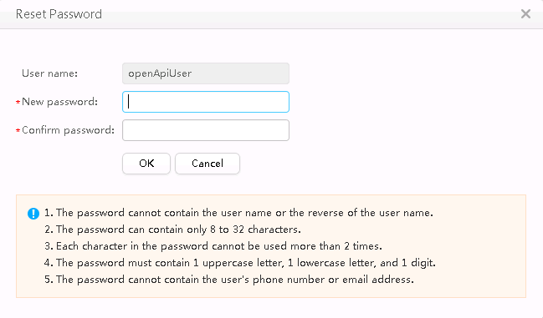

* 1. Enter a password in **New password** and **Confirm password**.
  2. Click **OK**. The password is reset.
* The eSight northbound interface user is locked.

To unlock a user, perform the following steps:

* 1. Log in to the eSight WebUI.
  2. Choose **System** > **User Management** > **User**.

The **User** page is displayed.

* 1. Click to set **Status** of the eSight northbound interface user to **Enabled**.



Unlocking a user



* A whitelist has not been set.

By default, a whitelist of eSight northbound ports is configured. To add an eSight properly, you must add the IP address of the server where vCenter is located to the whitelist of eSight northbound ports. To set the whitelist, perform the following steps:

* 1. Log in to the eSight WebUI.
  2. Choose **System** > **Northbound Integration** > **Third-party System** > **Create**.

The **Third-party System** page is displayed, as shown in Figure 4-4.

Third-party System

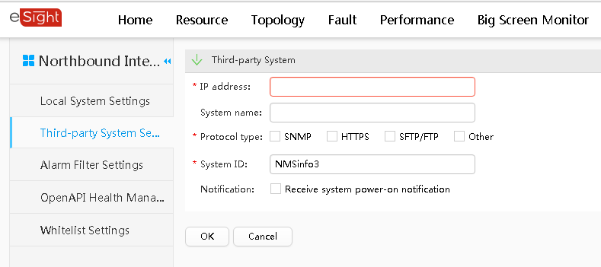

* 1. Set the following parameters:
  2. **IP address**: IP address of the vCenter server
  3. **Protocol type**: HTTPS
  4. **System ID**: Retain the default value or enter a new value. The value can be an IP address or a string of 1 to 64 characters, including digits (0-9), lowercase letters (a-z), uppercase letters (A-Z), and special characters @_- (), .^$~`!.
  5. Click **OK**.

The IP address of the vCenter server is successfully added to the whitelist, as shown in Figure 4-5.

vCenter server successfully added to the whitelist

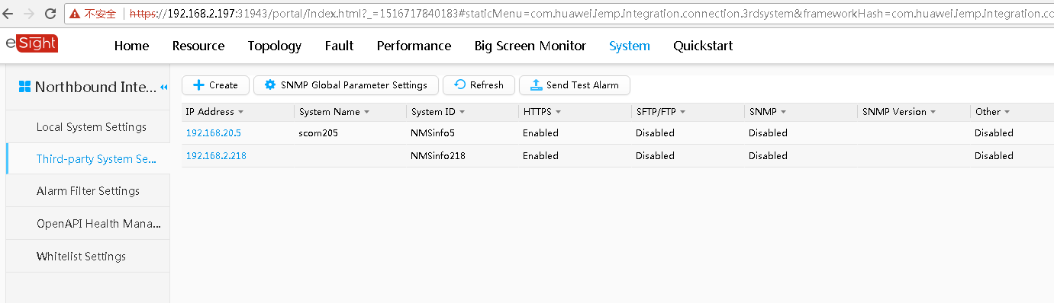

## Failed to Deploy an OS

Symptom and Cause Analysis

| Symptom | Cause Analysis |
| --- | --- |
| The message "Failed to mount ServiceCD" is displayed. | * The server is mounted and occupied by other virtual media. * SNMP V3 protocol parameters of a server are incorrectly configured when the server is added to eSight. |
| The system displays a message indicating that the ServiceCD does not exist or the file name is incorrect. | The eSight installation path does not contain the ServiceCD software or the ServiceCD file name is incorrect. |
| Others | * No RAID is created in the RAID controller card. * The server or RAID controller card does not support the deployed OS. |

Solution

* The server is mounted and occupied by other virtual media.

Unmount the virtual media by performing the following steps:

* 1. Log in to iBMC WebUI.
  2. Choose **Remote Console** > **Virtual Media**.

The **Virtual Media** page is displayed.

Virtual Media

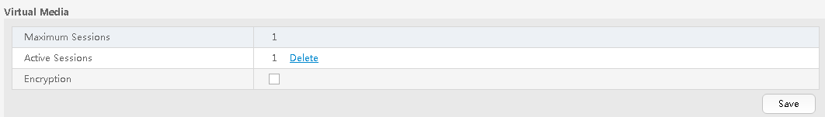

* 1. If the value of **Active Sessions** is **1**, the virtual media has been mounted.

Click **Delete**. The **Confirm** dialog box is displayed.

Confirm

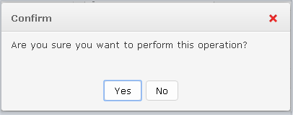

* 1. Select **Yes** to unmount the virtual media.
  2. Perform the deployment task again. For details, see 3.2.2 Deploying an OS.
* SNMP V3 protocol parameters of a server are incorrectly configured when the server is added to eSight.

Check whether SNMP V3 parameters are correct.

* 1. Log in to the eSight WebUI.
  2. Choose **Resource** > **Server** > **Server Device** > **Rack Server**.

The rack server page is displayed.

Rack server page

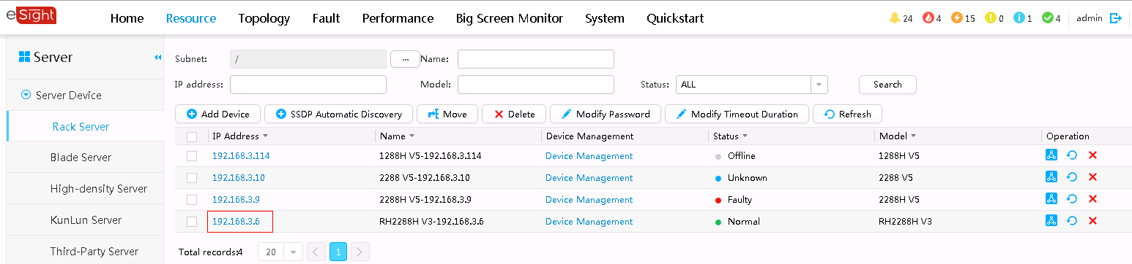

* 1. Select a server. The detailed server information is displayed.
  2. Choose **Settings** > **Protocol Parameters**.

Viewing detailed server information

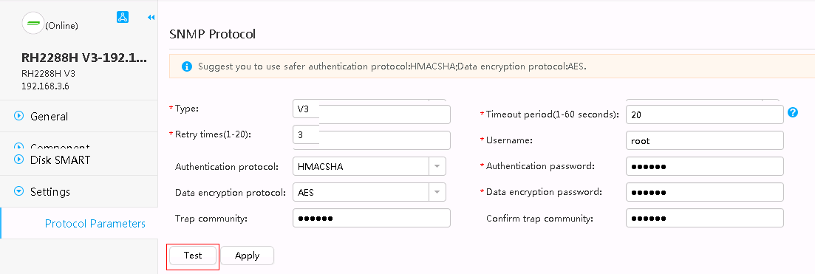

* 1. Click **Test** to test the SNMP protocol.
  2. If the **Succeeded** dialog box is displayed, the SNMP protocol is correct.
  3. If the **Error** dialog box is displayed, the SNMP protocol is incorrect. Enter correct SNMP V3 parameters.

SNMP Protocol

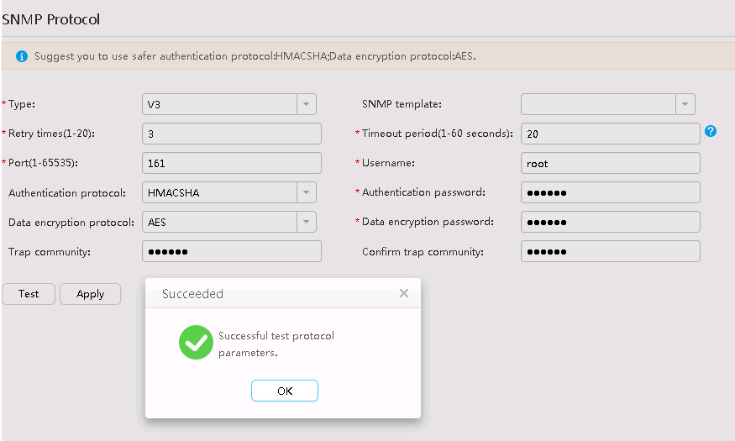

* The eSight installation path does not contain the ServiceCD software or the ServiceCD file name is incorrect.
  1. Download the ServiceCD from the **Software Download** tab on the [**FusionServer Tools**](https://support.huawei.com/enterprise/en/servers/fusionserver-tools-pid-21015513/software) page at [Huawei Enterprise](http://support.huawei.com/enterprise/en/index.html) support website.
  2. Decompress the downloaded software package.

Decompressed ServiceCD software package

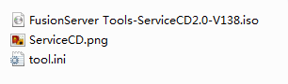

* 1. Change the name of the **.iso** file to **FusionServer Tools-ServiceCD2.0-V110.iso**.
  2. Copy **FusionServer Tools-ServiceCD2.0-V110.iso** to eSight installation directory**\AppBase\var\iemp\data\ftp\**.
* No RAID is created in the RAID controller card.

For details about how to create a RAID, see 3.2.3.4 Configuring RAID.

* The server or RAID controller card does not support the deployed OS.

You can check the compatibility between the server, OS, and RAID controller card by using the [Huawei Server Compatibility Checker](http://support.huawei.com/onlinetoolsweb/ftca/indexEn?serise=2).

Ensure that Note1 is present in the **Notes** column.

Checking the OS compatibility

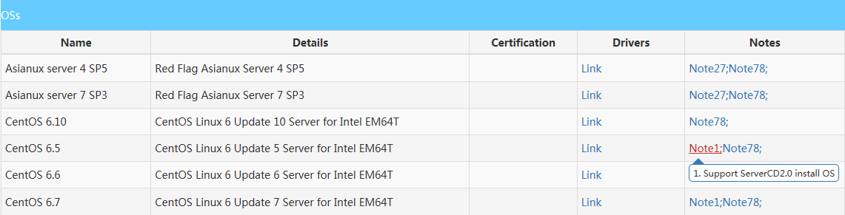

## Failed to Upload an Upgrade Package

Symptom

The message "The description of the firmware type does not match the actual firmware type" is displayed.



Cause

The downloaded driver package is not applicable.

Solution

1. Log in to [Huawei Enterprise](http://support.huawei.com/enterprise/en/index.html) support website.
2. In the **PRODUCT SUPPORT** area, choose **Enterprise Data Center** > **Servers** > **Server Management Software** > **FusionServer iDriver**.
3. Click the **FusionServer iDriver** tab.
4. Click the desired driver version.
5. Download the correct driver package. Ensure that the driver package contains the **driver.xml** file.

## How to Add a Server ESXi System to a vCenter Cluster

On the vCenter WebUI, choose **Home** > **Inventories** > **Hosts and Clusters**.

The **Hosts and Clusters** page is displayed.

Choose **Datacenter** from the shortcut menu.

Choose **New Cluster**.

The **New Cluster** page is displayed, as shown in Figure 4-13.

New Cluster page

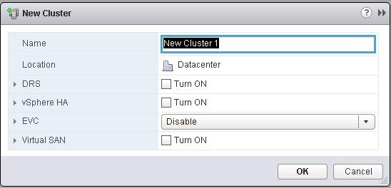

Enter a cluster name in **Name**, and click **OK**.

Right-click the newly created cluster.

Choose **Add Host...**.

The **Add Host** page is displayed, as shown in Figure 4-14.

Add Host page

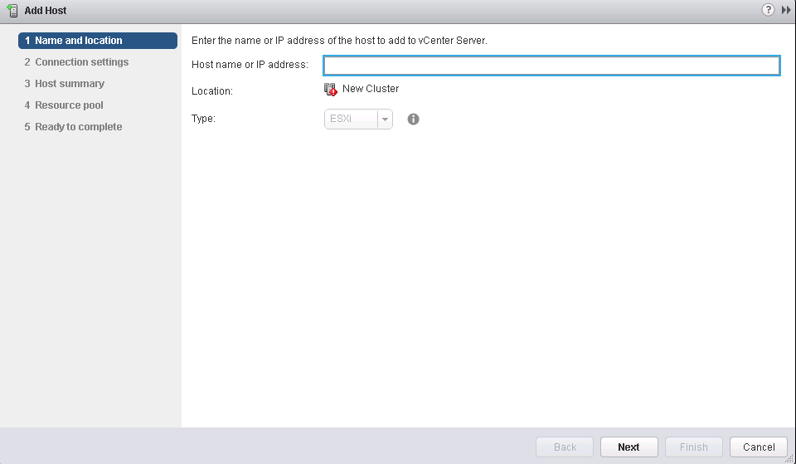

* On the **Name and location** page, enter the IP address of the server ESXi system.
* On the **Connection settings** page, enter the user name and password of the server ESXi system.

Click **Finish**. The ESXi system is added.

----End

## Icon of the eSight For vCenter Not Displayed in the vCenter Home Page

Symptom

After the eSight for vCenter plug-in is installed, the user exits and re-logs in to vCenter. However, the eSight for vCenter plug-in icon is not displayed on the vCenter home page.

Solution

Check whether a firewall is enabled in the system where the Huawei vCenter plug-in deployment program is located.

* If yes, disable the firewall (for details, see Step 3 in section 2.1 Installing the Huawei vCenter Plug-In), and go to Step 2.
* If no, go to Step 2.

Restart the vCenter service.

* Restart vCenter in the Windows environment.
  1. Access the Windows CLI.
  2. Run the following command to stop the vCenter service:

"C:\Program Files\VMware\vCenter Server\bin\service-control.bat" --stop --all

* 1. Run the following command to start the vCenter service:

"C:\Program Files\VMware\vCenter Server\bin\service-control.bat" --start --all

* Restart vCenter in the Linux environment.
  1. Access the Linux CLI as user **root** by using the SSH tool.
  2. Run the following command to stop the vCenter service:

service-control --stop --all

* 1. Run the following command to start the vCenter service:

service-control --start --all

Check whether the eSight for vCenter plug-in icon is displayed on the vCenter **home** page.

* If yes, no further action is required.
* If no, go to Step 4.

Log in to **https://*vCenter IP*/mob/?moid=ExtensionManager** to view the vCenter server information, as shown in Figure 4-15.

vCenter server information

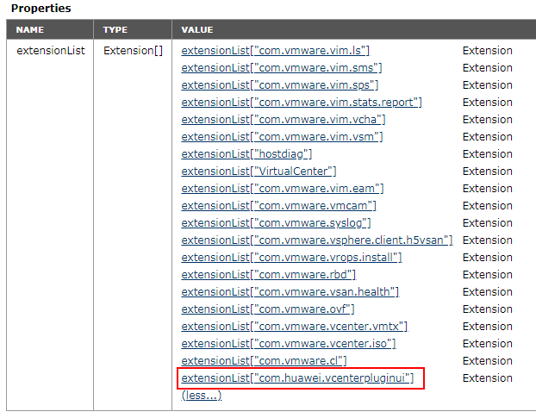

Click **com.huawei.fdvcenterpluginui** to view the Huawei vCenter plug-in information, as shown in Figure 4-16.

Huawei vCenter plug-in information

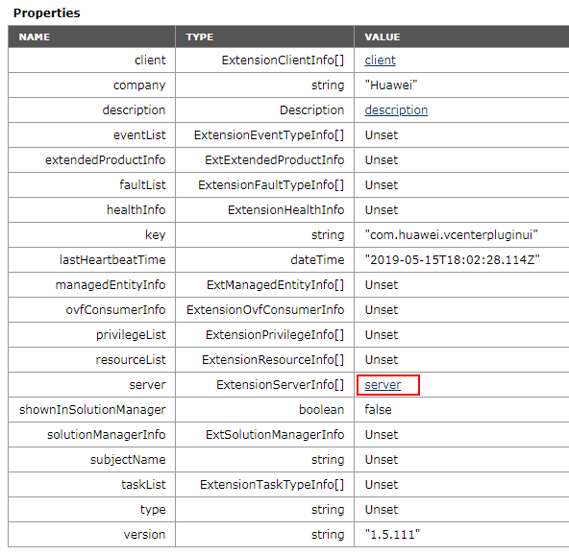

Click **server** to view the details of the **server** field, as shown in Figure 4-17.

Information about the server field

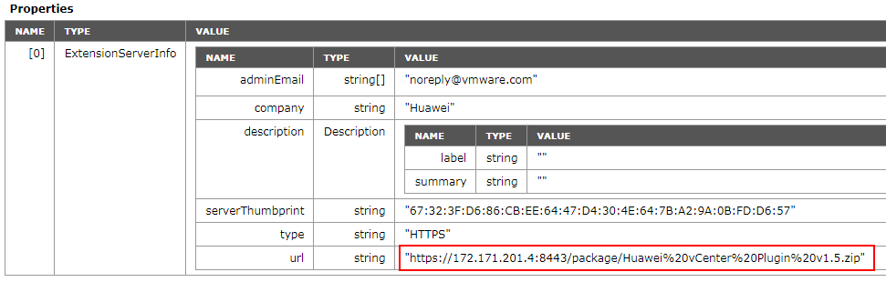

Check whether the IP address can be connected to the Huawei vCenter plug-in.

* If yes, go to Step 8.
* If no, modify the network configuration until the IP address is connected to the Huawei vCenter plug-in, and go to Step 8.

Reinstall the Huawei vCenter plug-in.

1. For details about uninstalling the Huawei vCenter plug-in, see 2.2 Uninstalling the Huawei vCenter Plug-in.
2. For details about installing the Huawei vCenter plug-in, see 2.1 Installing the Huawei vCenter Plug-In.
3. Log in to the Huawei vCenter plug-in to view the icon.

----End

## Failed to Start the Huawei vCenter Plug-in Installation Program and Deployment Program

Symptom

The Huawei vCenter plug-in installation program and deployment program fail to start, and a message is displayed, indicating that the system cannot run the keytool program.

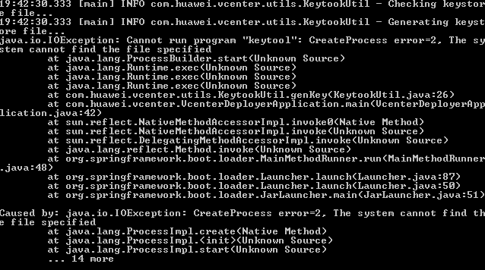

Solution

In the Java installation directory, check whether the **keytool.exe** file exists in the **bin** directory.

* If no, reinstall Java and go to Step 2.
* If yes, go to Step 2.

Check whether the Java installation directory is added to the environment variable.

* If no, add the Java installation directory to the environment variable by referring to Step 2 in section 2.1 Installing the Huawei vCenter Plug-In, and go to Step 3.
* If yes, go to Step 3.

Run the **CMD** command again.

----End

## On the Huawei vCenter Plugin Update Program Page, "Please put zip file and refresh the page" Is Displayed

Symptom

On the **Huawei vCenter Plugin Update Program** page, the installation and deployment of the Huawei vCenter plug-in fail, and the message "Please put zip file and refresh the page" is displayed.

Solution

Save the installation and deployment package and the .jar file of the installation program to the same directory, and log in to the page again.

## RAID Controller Card Slot Number Is Empty in the RAID Controller Card Template Details

Symptom

In the RAID controller card template details, the slot number of the RAID controller card is empty and cannot be viewed, as shown in the following figure.

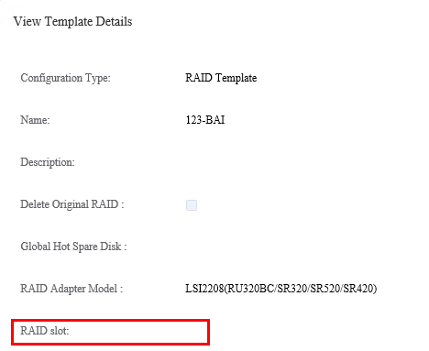

Solution

When creating a RAID controller card template, manually enter the slot number of the RAID controller card in the **Description** text box. The procedure is as follows:

On the vCenter WebUI, choose **Home** > **eSight For vCenter**.

The **eSight For vCenter** page is displayed.

Choose **Server** > **Template Management**.

The **Template Management** page is displayed.

Click **Create Template**.

The page for creating a template is displayed.

Select **RAID Template** from the **Configuration Type** drop-down list box.

In the **Description** text box, enter the slot number of the RAID controller card (for example, RAID Slot 0), as shown in the following figure.

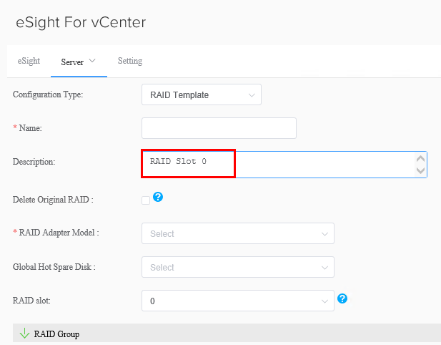

Set the required parameters and click **OK**.

The RAID template is created.

You can view the slot number of the RAID controller card in the **Description** column in RAID controller card template details.

----End

1. Obtaining Help
   1. Preparing to Contact Huawei Technical Support

If a fault persists during routine maintenance or troubleshooting, contact Huawei technical support.

To rectify a fault, make the following preparations before you contact Huawei technical support.

Collecting Fault Information

You need to collect the following information:

* Your company name and detailed address
* Name and telephone number of the contact person
* Time when the fault occurred
* Fault symptom
* Device type and software version
* Measures taken after the fault occurred and results
* Fault severity and deadline for rectifying the fault

Preparing for Debugging

When you seek technical support, Huawei technical support may ask you to perform some operations to further collect fault information or even rectify the fault. You need to make preparations before seeking technical support. For example, prepare spare server parts and controller cards, screwdrivers, screws, serial cables, network cables, and other necessary objects.

* 1. Obtaining Help from Huawei Support Website

Huawei provides timely and efficient technical support over local offices, secondary technical support systems, telephones, remote technologies, and onsite instructions.

Huawei technical support system consists of:

* Technical Support Department at Huawei Headquarters
* Technical support centers in local offices
* Huawei support website
* Customer service center

Huawei support website: <http://support.huawei.com/enterprise>

To view the latest product documentation at http://support.huawei.com, perform the following steps:

1. Log in to <http://support.huawei.com/enterprise>.
2. Click **Login**. The **Login** page is displayed.
3. Enter your user name, password, and verification code, and click **Login**. The **Technical Support** page is displayed.
4. In the navigation tree, click **TECHNICAL SUPPORT > Technical Support > Product and Solution Support** and select a product manual based on the product name.



Alternatively, you can quickly locate a product manual by entering a keyword in the **Search** text box in the upper right corner of the web page.